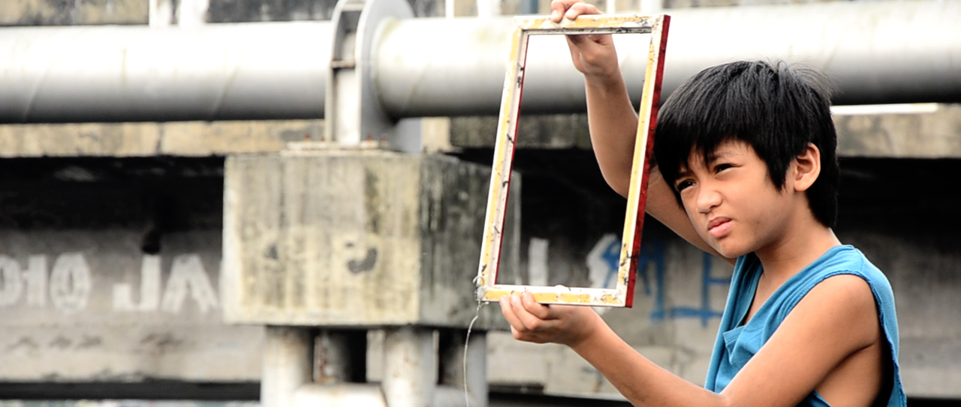
PIPO
Directed by Richard Soriano Legaspi
2015/ Short Film / Coloured / English Subtitles / TRT 19:54 / Philippines-Italy
Shooting Location: Tinajeros, Santolan Malabon, Luneta, Manila

Short Synopsis:
“A boy dreams of having his family picture taken only to find out that what is more important is that he still has a loving family by his side more than anything else.”
Actors: Lou Veloso, Chanel Latorre, Ramon Palencia, Katherine Carel and Maliksi Morales
Long Synopsis:
Not wanting to be jeered for not having a family photo, the little boy wrecked his brain and even made up rumors to ask the photographer to take a picture of his family at a lower price. However, it is not until something happened that he found out that a family with love is more important than anything else. Through the boy’s story, the problems of poverty and environment can also be seen in the film.

Website: http://cycloneloopfilmprod.wordpress.com/si-pipo-at-si-kamuning/
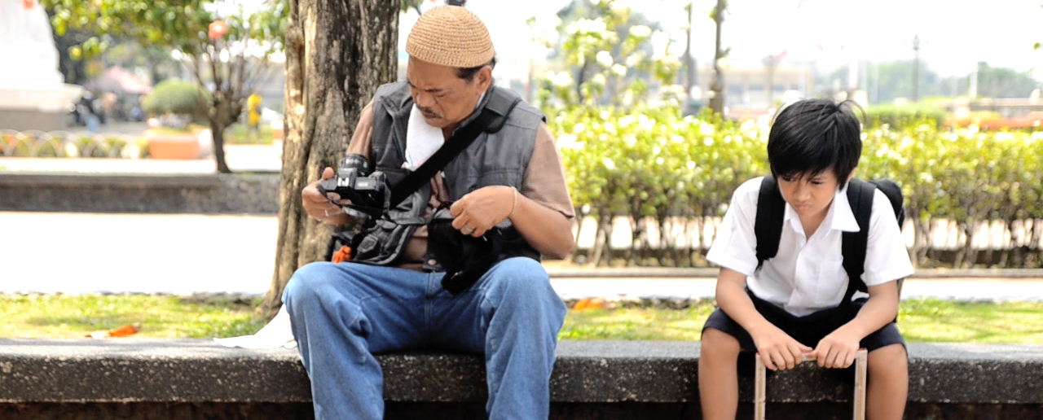

FESTIVALS AND SCREENINGS:

Winner, Audience Prize, GATFFEST Film Festival, Kingston, Jamaica 2017
Exhibition, 3rd International Film Festival on the Island -FECISLA, Colombia, 2017
In Competition, International Children’s Film Festival Bangladesh 2016
Official Philippine Entry, South East Asian Prix Jeunesse Awards sa 2017
Winner, Best Short Film, SineBata Film Festival (Professional Category) 2016
In Competition, 4th ShortCup World Film Festival, Brazil 2017
In Competition, 5th Delhi Shorts International Film Festival – India 2016
Official Selection, Festival Internacional de Cine Universitario Allucinema, Mexico 2016
3Little Wolves Film Festival – Slovenia 2016
In Competition, International Short Film Festival VISION, Siberia – Russia 2016
Special Screening, retrospective of Monsoon Asia x SeeMe Mobile Film Festival 2016
In Competition, Venice Film Week – Italy 2016
In Competition, International Short Film Festival "IndieCrete" Greece 2016
Official Selection, Festival Internacional de Cine y Audiovisual Infantil y Juvenil, Colombia 2016
Official Selection, Festival Internacional de Cine y Audiovisual Infantil y Juvenil, Venezuela 2016
Official Selection, Venice Film Week 2016
Official Selection, International Film Festival of Odisha, India 2016
In Competition, Smile International Film Festival for Children and Youth, India 2015
In Competition, Goldensun International Film Festival, Malta 2015
In Competition, Athens International Digital Film Festival, Greece 2015
In Competition, Caminhos Film Festival, Portugal 2015
In Exhibition, Monsoon Asia Film Festival, Taiwan 2015
Davis International Film Festival, San Francisco 2015
Tuzla Film Festival, Bosnia and Herzegovina 2015
Festival Corto Creativo, Mexico 2015
Open-Air Filmfest Weiterstadt, Germany 2015
Cittadellarte-Fondazione Pistoletto screening, Italy, 2015
Children’s International Film Festival, Dubai UAE, 2015, International Premiere

