BASIC INFO

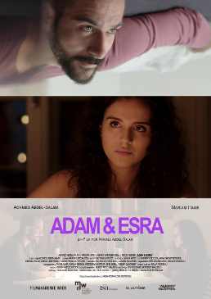
TITLE: Adam & Esra
WRITER/DIRECTOR Achmed Abdel-Salam
PRODUCER Achmed Abdel-Salam, Saskia Arth
DIRECTOR OF PHOTOGRAPHY Mathias Seebacher
EDITOR Matthias Writze
CAST: Achmed Abdel-Salam, Mariam Hage, Alexey Hartlieb-Shea
FESTIVALS: Landshut Short Film Festival (Bavaria, Germany)

LOGLINE

Upon meeting the very down-to-earth Esra, narcissistic Adam sets out to conquer her. But his superficiality soon becomes a stumbling block - and bit by bit, his facade starts to crack.

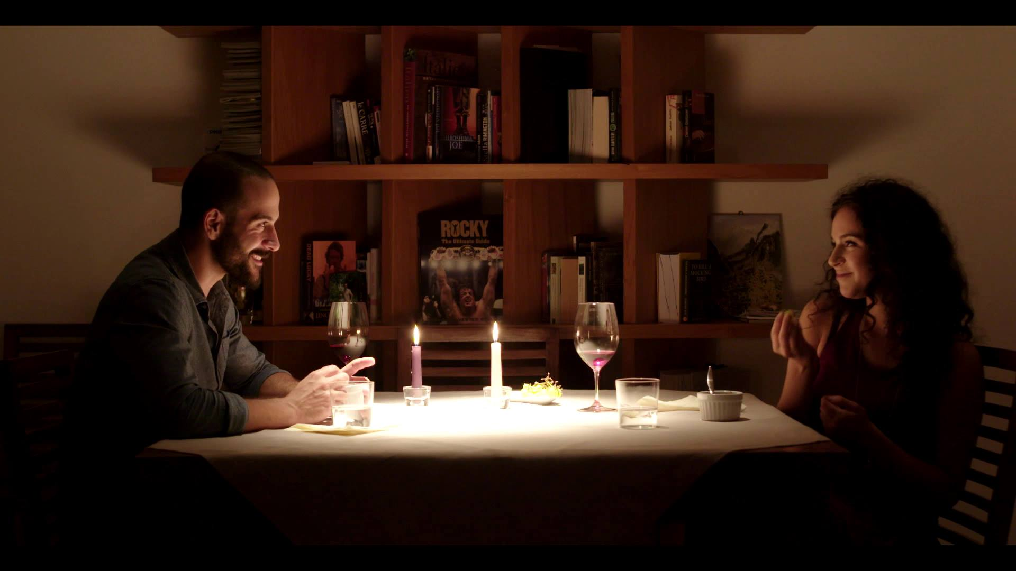

SYNOPSIS

Adam is in his early thirties and has got it all - good job, big flat and an athletic body. He's used to being at the center of people's attention, loves to talk about himself. When he meets Esra, a quick-witted young woman, who isn't impressed by him at all, her disinterest triggers his urge to conquer her. Esra reluctantly accepts Adam‘s invitation for dinner and they end up having a good time together, slowly bonding. The mood suddenly turns, when Adam suffers a severe panic attack. He ruins the night with his emotional withdrawal, not being able to show even the slightest sign of weakness.
They meet again for coffee only for Esra to tell him she has no interest in him. Adam has a hard time dealing with her rejection, it bothers him that he's left such a bad impression. He needs to fix it and confront her one more time.
Writer/director Achmed Abdel-Salam used an artistically challenging approach, making use of improvisational acting while directing the scenes from within. Playing the lead himself allowed him to provoke authentic reactions from the actors, giving the film a lifelike feel.

DIRECTOR’S THOUGHTS ON
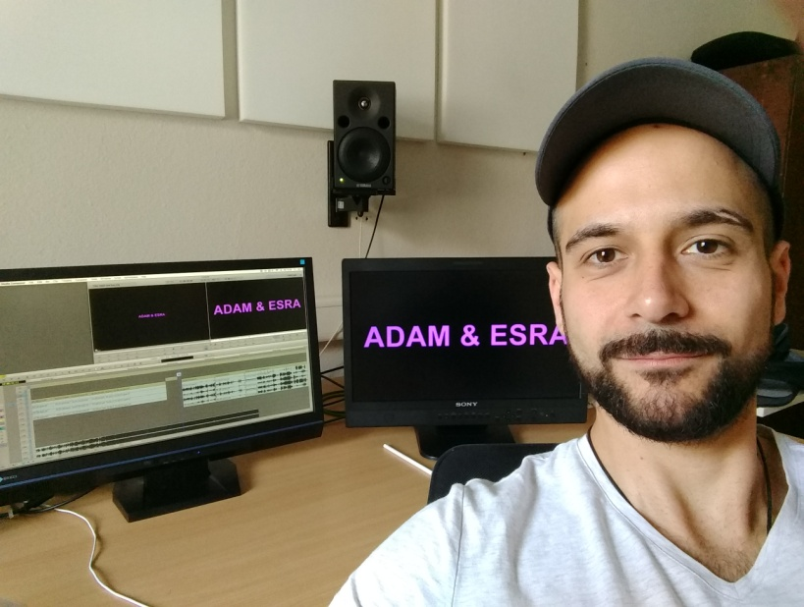

The inspiration
We live in world where first impressions count. Too often it’s not our qualifications that decide if we get a job, it’s the way we look. A world which is being led by narcissists, one in which we are constantly busy creating near perfect virtual versions of our lives and ourselves through social media platforms. I’ve been interested in narcissism for a long time, as I think it’s our era’s collective disease.
So, the idea for the film actually was the idea for a character. A narcissist, a man who has certain values that have been formed by a life-long confrontation with the media and how it (still) transports a questionable image of masculinity. Adam thinks he needs to fulfill an unrealistic ideal, and he has done a pretty good job so far – he’s successful and healthy. At least that’s how it seems on the outside. The strict diet, the grueling workout routine and the constant concern with his looks have taken their toll on him. But he doesn’t even notice it, until he’s trapped in a vicious circle.
The characters
Adam is a narcissist, no doubt about that. He likes looking at himself in the mirror, seeing the results oft the hard work he’s put in. At the same time he will never be fully satisfied with himself. What seems to be a paradox at first, is actually very common when it comes to narcissism. Adam is plagued by a strong sense of inferiority, thus having created an unhealthy relationship with himself. The result, of course, is the unability to form stable relationships with others. Adam puts on a mask, he tries to be as strong and perfect as possible. As good as it gets. But he needs the admiration of peolple around him, even that of strangers. When he doesn’t get it – or even worse – has to deal with rejection he’s facing a severe crisis. Which is exactly what happens to him in our short film.
Esra on the other hand is a very down-to earth person. Looks don’t matter that much to her, she really wants to bond. She sees something in Adam, that’s worth investing. But soon he shows her that he’s clearly dealing with issues, driving her to end the romance before it has even started. Despite Adam’s very off-putting behaviour, Esra brings up the courage to tell him in person that she has no interest in seeing him again. She’s not giving in to his provocative teasing, keeping a cool head and thereby forcing him to really deal with himself. She is the stronger character, the actual emotional core of the film.
The casting
Of course it’s no coincidence that Adam is trying to conquer a woman that could go as his female counterpart. So, in a metaphorical sense that we’ve visualized he’s trying to conquer himself. That’s why the casting was such an important part of pre-production and I’m really glad we found the perfect Esra in Mariam Hage.
Also on a political scale it was important to me that we’d go down that road. Having two lead actors with an obvious arabic background without making it an issue, is a rare move. At the end of the day it just doesn’t matter. It’s the story of two people and it works on a universal level. In Austria casting for film, tv and theater is still not really diverse. Actresses and actors with a foreign look, who’s skin might be a bit darker usually don’t land any roles which aren’t about their ethnic look. Most of the time it’s directly adressed or even the subject of the story. I find that approach to be a bit cowardly. Also, it neither reflects our multicultural society, nor does it represent reality. I think that’s shame and I want to provide some change with my films.
The title
Well, obvioulsy it references Adam and Eve, but it’s not about the fall of mankind. To me it was always about images and reflections. About our ability of self-awareness. Adam is also the hebrew word for man. Adam was the very first man. The epitome of masculinity. And that’s what our protagonist strives for. He wants to be masculine, heroic, successful and – most importantly – admired. Simply put, that’s all it comes down to with classic narcissists. So, the use of the name Adam seemed very fitting to me.
Regarding Esra I really just wanted to pick a name that was somehow similar in sound to Eva, which is the German form of Eve. (In German the whole wordplay works better.) Genesis says that Adam was only able to recognize himself as a man, once Eve was created. He needed a woman to be a man. Regarding the characters and the overall theme of the film, I found that the title added another level to it.
The concept
I’ve always felt a fascination for improvisation, I find it to be very helpful in freeing the creative process. Having acted in several short films that made use of at least partial improv, I knew that you could achieve a level of authenticity when you let actors rely in their instincts. In a way Adam & Esra was an experiment from the start. It was clear that I wanted to tell the story of a narcissist facing rejection. In a very early stage I decided to play the role myself, because I wanted to direct the scenes from within.
There was no real script, just a kind of framwork, that sketched the scenes. Before we started shooting, I wrote a whole biography for Esra, which I handed to Mariam. We met several times and discussed the character, but ultimately I wanted her to make Esra her own. I didn’t want to know everything about the character, so Mariam could suprise me on set.
Portraying Adam while directing allowed me to take the scenes in different directions, whenever I felt the energy was not right. I surprised the actors with my (at times big) changes. Each take would differ from the one before, provoking genuinely surprised reactions from the cast.
While I thoroughly enjoyed that approach, for our DoP Mathias Seebacher the shoot was very challenging, on-camera improvisation is pretty unpredictable, making it difficult to do fine lighting setups, since the actors might move unexpectedly.
The editing process took around eight to nine months, not only beacuse shots would sometimes not connect. The sheer amount of material would have allowed to make three different shorts. So it was a matter of focussing and shortening.

In retrospect
It was daring, it was exhausting. A thrilling ride and a great experience. My work on Adam & Esra, where I served as writer, co-producer, director and lead has taught me a lot about what filmmaking actually means. And I honestly enjoyed every moment of it.

ACHMED ABDEL-SALAM
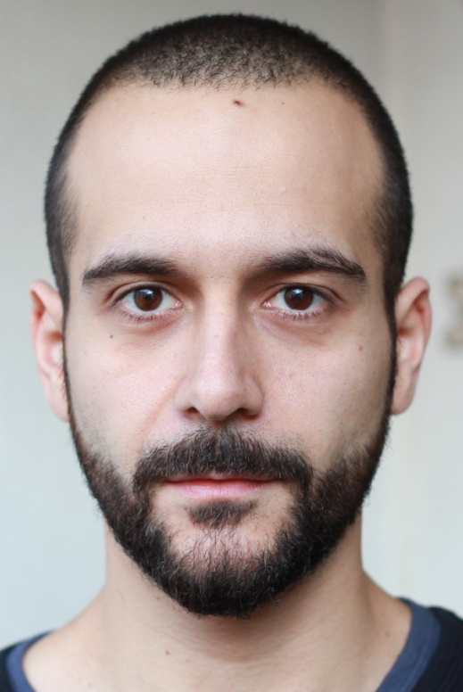
Leading Actor/Writer/Director/

Achmed Abdel-Salam was born in 1983 in Vienna, Austria. He studied Screenwriting and Dramaturgy at the Filmacadamy Vienna, receiving his Bachelor’s Degree with Destinction in 2014, and is currently attending the Master’s Program. Achmed has written numerous shorts and (still unproduced) feature films. In 2013 his treatment The Edge won him the Carl Mayer Young Talent Prize at the Diagonale – Festival of Austrian Film. The following year he was awarded a screenwriting scholarship by the Literar Mechana, an Austrian copyright collecting society. In 2017 he became a finalist in the Austrian Script Writing Competition If she can see it, she can be it, focussing on strong female protagonists. The Tokyo Foundation has recently selected him for a SYLFF Young Leaders Fellowship. Currently he is working on a horror film and is part of a writers‘ room, developing a TV show.

FILMOGRAPHY as director

2017: Adam & Esra/Short/19 min.
written and directed by

2017: Auslassungen (Omissions)/ Filmessay/30 min.
written, filmed and edited by

2016: VIDEO/Short/9 min.
written and directed by

2013: FREIGÄNGER (TAGGED)/Short/11 min.
written and directed by
www.abdel-salam.at

FILMOGRAPHY as actor
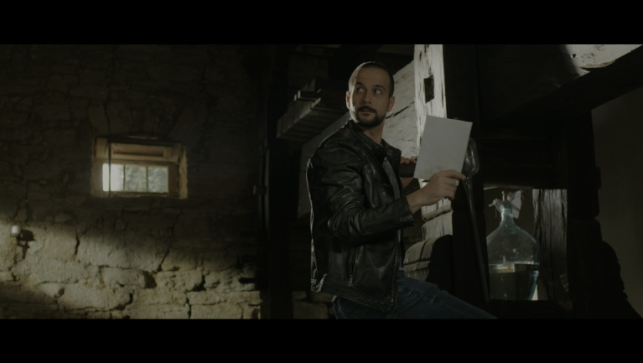
2018: Glossary of Broken Dreams / Modern Subject / D: J. Grenzfurthner / monochrom
2018: The Fortress / Lead: Karim / D: Alexey Hertlieb-Shea (in post-production)
2017: Adam & Esra / Lead: Adam / D: Achmed Abdel-Salam / Filmacademy Vienna
2017: Damals / Lead: Er / D: Georg Ganschitter, Verena Mühling
2016: The Wedding / Bit Part: Paul / D: Sebastian Mayr / Filmacademy Vienna
2016: VIDEO / Lead: Man / D: Achmed Abdel-Salam / Filmacademy Vienna
2016: Der Besuch der kleinen Dame / Lead: Achmed / D: Jessica Lind, Filmacademy Vienna
2015: Aura of Avery / Lead: Viktor / D: Marcel Darwish / SAE Vienna
2015: We used to be cool / Young father / D: Marie Kreutzer / Novotny&Novotny
2015: SOKO Donau (1 Episode) / Selim Al Khatib / D: Holger Barthel / Satel Film
2014: Copstories (2 Episodes) / Kamal / D: C. Schier, M. Riebl / Gebhardt Productions
2014: Die G’stettensaga / Zombie / D: J. Grenzfurthner, monochrom
2014: 1805 – A Town’s Tale / Lead: Phillipe / D: Walter Bednarik / Refos Film
2013: UNCHARTED – Eye of Indra / Lead: Nathan Drake / D: Constantin Prochazka / SAE Vienna
2013: Die Auslöschung / Flower Seller / D: Nikolaus Leytner / Monafilm
2012: Earthmoving / Bit Part: Cab Driver / D: J. Grenzfurthner / monochrom, Golden Girls
2011: Gabriel / Lead: Armin / D: M. Seebacher / Filmacademy Vienna
2010: ABSEITS / Lead: Convict / D: Béla Baptiste / Filmacademy Vienna
2009: SERKAN - Das Film/ Serkan / D: Bernhard Goeth / BMC
Showreel:
https://vimeo.com/263379620
Represented by Jack & Jill International Talent Agency
http://www.jackjillcasting.com/?model=achmed-abdel-salam
https://www.imdb.com/name/nm4838246/?ref_=fn_al_nm_1
MARIAM HAGE
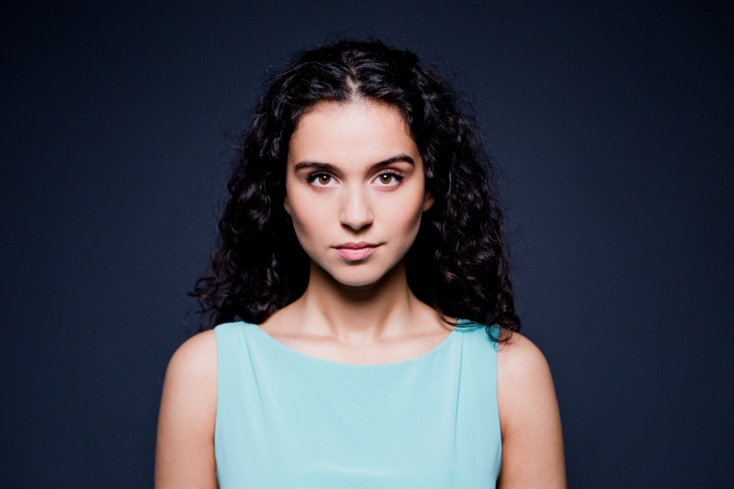
Actress - Esra

Mariam Hage was born in Vienna, Austria. In an effort to lose her shyness, she participated in an acting course at her school, when she was 10 years old. There she discovered her passion and love for acting. Throughout her school years, she continued to do theater, even during her stay in California, where she lived for a year, when she was 15. After finishing High School in Vienna, she started studying history and philosophy, before finally deciding to give it all she’s got and make a profession out of her passion. Since then she has been working on her craft and has appeared in numerous short films, such as ADAM & ESRA, and also stars in the main cast of an Austrian TV series called “TRAKEHNERBLUT”.

FILMOGRAPHY
2017: Trakehnerblut/ Gestüt Hochstetten | SamFilm | TV Series | Andreas Herzog, Christopher Schier | Main Cast
201: Adam & Esra | Filmakademie Wien | Short Film | Achmed Abdel-Salam | Lead
2016: zehn.zwanzig | Unpleasant Production | Feature Film | Rafael Bettschart | Lead
2016: Abberatio Ictus | Short Film | Naima Schmidt | Lead
2016: Residency | TEO Film | Short Film | Parisa Ghasemi, Ashkan Nematian | Lead
2016: Wie werde ich sie los – Remoe | Music Video| Remoe & Jumpa | Gökhan Güler | Lead
2015: Wienerland | Derringer Entertainment | Web Series | Jan Woletz, Stefan Polasek
2015: Wie schmeckt eigentlich Behinderung | Social Awareness Spot | Guy Lichtenstein | Lead
Imdb: https://www.imdb.com/name/nm9428123/?ref_=fn_al_nm_1
Represented by Stella Fürst: https://www.agenturfuerst.at/newcomer-1/hage/
MATHIAS SEEBACHER
Director of Photography

Born 1989 in Klagenfurt, Austria. Mathias went to an art school in Villach, Austria, for his high school diploma in 2008. After that he started working as an assitant photographer and in filmproduction. In 2009 he was employed as a photographer in a studio in Klagenfurt. 2010 he starts his studys of film directing in Vienna Film Academy with professor Michael Haneke and professor Wolgang Murnberger. He is working as a director, DOP, gaffer and best boy for feature films and commercials in Vienna.

FILMOGRAPHY as DOP, Gaffer and Best Boy
Feature Films unless otherwise stated:
2018: Joy (in postproduction) (D: Sudabeh Mortezai; P: Freibeuter-Film) – Gaffer
2018: Tokyo (D: Catrin Freundlinger, P: FAK Vienna) – DOP (Documentary, 60min)
2017: The Dark (D: Justin P. Lange; P: Dor-Film & First Love Films) – Best Boy
2017: Die Einsiedler (D: Ronny Trocker; P: Golden Girls / Zischlermann) – Gaffer
2017: Die Hochzeit (D: Sebastian Mayr; P: FAK Vienna) – Gaffer (Short, 42min)
2017: Brüder der Nacht (D: Patric Chiha; P: WildArt Film) - Gaffer
2016: All The Tired Horses (D: Sebastian Mayr; P: FAK Vienna) – Gaffer (Short, 24min)
2016: Alles Nicht Echt (D: Sebastian Longariva; P: FAK Vienna) – DOP (Short, 10min)
2014: Freigänger (D: Achmed Abdel-Salam; P: FAK Vienna) – DOP (Short, 13min)
MATTHIAS WRITZE
Editor
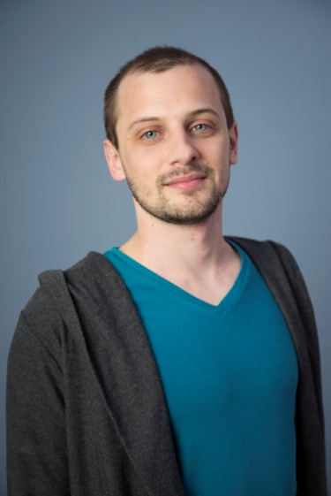
Matthias Writze studied journalism at the Vienna University of Applied Sciences and worked as freelance journalist for weekly newspaper „Falter“. Starting 2010 he studied „Screenwriting and Dramaturgy“ and „Film Editing“ at the Filmacademy of Vienna. He is currently working as editor, script consultant and screenwriter in Vienna
FILMOGRAPHY

2018: ADAM UND ESRA
Short Film I 20 min
Director: Achmed Abdel-Salam I Position: Editor and Story Consultant
2017: MILLENNIALS
TV Documentary, ORF I 45 min
Director: Jasmin Baumgartner I Position: Editor and Story Consultant
WANNABE
Short Film and Web-Series I 30 min and 15 x 4 min
Director: Jannis Lenz I Position: Screenwriter and Co-Editor
MATHIAS
Short Film I 30 min
Director: Clara Stern I Position: Editor and Story Consultant
2016 UNMENSCH (INHUMAN)
Short Film I 24 min
Director: Jasmin Baumgartner I Position: Editor and Story Consultant
2015 человек работа (MAN’S WORK)
Short Film I 17 min
Regie: Marina Stepanska I Position: Editor
SASKIA ARTH
Producer
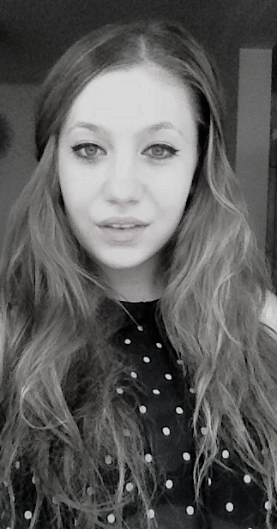

Born in Vienna. Bachelor’s studies „Film Producing“ at the Filmacademy in Vienna since 2017.

FILMOGRAPHY:
2017: Adam & Esra, short, D: Achmed Abdel-Salam
2016: Mathia, short, D: Clara Stern
2016: FUCKING DRAMA, short, D: Michael Podogil, AL
2016 : Schuld und Sühne Kurzfilm, D: Albert Meisl
2016: Am Himmel, short, D: Magdalena Chmielewska, AL
2016: Moving Water, music video Regie: Sebastian Mayr
2016: Der Standard, commercial, P: PPM
2016: Generalprobe, short, D: Jannis Lenz

CONTACT

Achmed Abdel-Salam
achmed@abdel-salam.at
0043 660 163 79 83

