The Production

"Manto Ki Shadi" (Manto’s Marriage) is produced by Shrivas Nydu and Ravi Buley for Pranati Nydu Films. The film is actually a writing by Saadat Hasan Manto. Ravi Buley does the photography and the film is designed, edited & directed by Shrivas Nydu; it will be uploaded online by Filmingo Channel.

The Story/Synopsis
The film recounts an interesting and witty episode of Sadat Hasan Manto’s life i.e. his marriage.
Manto is a great story writer from Urdu Literature. Relating psychoanalysis with human behaviour, he was arguably one of the best short story tellers of the 20th century, and one of the most controversial as well. When you register the collective madness that prevailed, during and after the Partition of India in 1947, no other author is close to the opus of Saadat Hassan Manto. He is acknowledged for his hard-hitting and heart-wrenching stories dealing with numerous facets of social sentiments. Though he lived a grave life, full of complications. But he always kept smiling seriously and anecdote of his marriage is literally funny at one end and seems dark humour at another i.e. how a talented man was crushed to circumstances.

Manto breathed the early Bombay dream. He spent a little time in the film industry and established himself as a writer and a cultural figure. He was a very humble and down to earth person. Though he was associated with many a celebrities in the film industry at that time, as this story shows, but he mentions those names very casually.

There was a time when he was living a very disgusting life and at the very same time his mother visited him. She was worried that he could not progress since he was not well educated. Just in a jest he told her that he was not earning because he didn’t have a family and what he is earning is sufficient for a single being. She somehow arranged his marriage. His joke turned into a serious matter. Without a penny in his pocket how he managed everything that’s the journey of this voyage called ‘Manto Ki Shadhi’ (Manto’s Marriage)
The admiration, however, shouldn’t be limited to this writing as it excels in several sides, expressly the sincerity. The writer Manto has rapidly knitted a number of things from his life and told them directly to the addressees. It makes you giggle and ends with saying that’s the life folks.

The Treatment

The piece is written in the form of first person and so it’s direct to the camera or say the viewers.

"The place was so full of bedbugs that they fell from the roof like rain. When my mother came over to see me at that filthy tiny room, she wept. She noticed my poverty and cried, for I had seen better days before."

Manto is writing his story for the people who wants the glimpses of his life. Since the narrative is intimate one so the full film is shot on camera close.

The utmost unique characteristic of Manto as a writer of this story is that he reenters his life to make exceptionally personal story, not just thematically personal, but discovers his own life, his youth, and his career that has carried us towards him. This film surely reveals all the concerns related to an artist as an individual and as well as the whole community.

Manto Ki Shadi (Manto’s Marriage)
Cast & Credits

Hindi |  | English
फिल्मिंगो के साथ |  | In association with Filmingo
प्रनति नायडू फिल्म्स प्रस्तुति |  | Pranati Nydu Films Presents
श्रीवास नायडू कृत |  | A Shrivas Nydu film
मंटो की शादी |  | Manto Ki Shadi / Manto’s Marriage
आत्मकथ्य ‘मेरी शादी’ का रूपांतरण |  | An Adaptation of the memoir  ‘Meri Shadi’ (My Marriage)
लेखक - सआदत हसन मंटो |  | Writer - Saadat Hasan Manto
पटकथा व छायांकन - रवि बुले |  | Script & Camera - Ravi Buley
ध्वनि - मनोज मिश्रा |  | Sound - Manoj Mishra
संगीत - विवेक श्रीवास्तव |  | Music - Vivek Shrivastav
कार्यकारी निर्माता - संजय बोहात |  | Line Producer - Sanjay Bohat
निर्माण सहयोग - भारती नायडू |  | Associate Producer - Bharti Nydu
निर्माण – श्रीवास नायडू व रवि बुले |  | Produced by Shrivas Nydu & Ravi Buley
परिकल्पना सम्पादन व निर्देशन – श्रीवास नायडू |  | Designed, Edited & Directed by  Shrivas Nydu
कलाकार (प्रवेश अनुसार)  श्रीवास नायडू  रवि बुले  संचयिता राव राणा  सोनाली बुले  मनोज मिश्रा  प्रेरणा राणा  सोहन राणा |  | Cast (In order of appearance)  Shrivas Nydu  Ravi Buley  Sanchaita Rao Rana  Sonali Buley  Manoj Mishra  Prerna Rana  Sohan Rana

सहायक निर्देशक - पल्लवी राणा |  | Assistant Director - Pallavi Rana
निर्माण संचालन - प्रतिष्ठा राणा |  | Production Coordination - Pratishtha Rana
कला सहायक - शान भट्ट |  | Art Assistance - Shaan Bhatt
रूप/केश सज्जा - कविता बुचड़े |  | Make Up/Hair - Kavita Buchade
वेशभूषा/मंच सामग्री - सोनाली बुले |  | Costumes/Props - Sonali Buley
परिवहन - ऋषि एंड अजय ट्रेवल्स |  | Transportation - Rishi & Ajay Travels
उपकरण - रियाज़ कैमरा रेंटल्स |  | Equipment - Riyaz Camera Rentals
कैमरा सहायक - बादल यादव |  | Camera Attendant - Badal Yadav
लाईट्स - समद लाईट्स एंड ग्रिप्स |  | Lights - Samad Lights & Grips
लाईट बॉयज़ - रफ़ीक अहमद, सुरेश नागर |  | Light Boys - Rafiq Ahmed, Suresh Nagar
बूम मैन - रमेश कुमार |  | Boom Man - Ramesh Kumar
स्पॉट बॉयज़ - जय कुशवाहा, इदरीस अली |  | Spot Boys - Jay Kushwaha, Idris Ali
लोकेशन  पोस्ट एंड टेलीग्राफ कॉलोनी, मुलुंड, मुंबई  श्री अष्टविनायक बिल्डिंग, मालवणी, मुंबई |  | Locations  P&T Colony, Mulund, Mumbai  Shri Ashtavinayak CHS, Malwani, Mumbai
ग्रॅफिक्स - रिज़वान अहमद |  | Graphics - Rizwan Ahmad
पोस्ट प्रडक्शन  द पोस्ट ज़ोन स्टूडियो, एवीएन स्टूडियो |  | Post Production  The Post Zone Studio, AVN Studio
सत्कार - शेफ राकेश भट्ट |  | Hospitality - Chef Rakesh Bhatt
टेक सपोर्ट - इक्लिक |  | Tech Support - eClick
© Pranati Nydu Films/Shrivas Nydu
2017

SHRIVAS NYDU
(Film Director)
The undersigned is a post graduate in Advertising and Public Relations. He has been associated with the field of film making for more than 15 years. Though graduated in graphic designing and worked as a visualizer in initial years of his career. As per the Films are concerned he has been associated with well known Indian production houses like Professional Management Group, Durga Khote Productions, Neo Films, Balaji Telefilms Ltd., Shri Ashtvinayak Cinevision Ltd., Eros International, Superads and Shashi Sumit Productions and so on. Following is the Professional Record…
Year | Assignment | Designation
2016 | Apart from making tens of TVC and corporate documentaries he has been the festival director for Rajasthan Govt’s International Festival of Short Films on Culture & Tourism (28-30th March 2016) | Director
2015 | 19 Films for the theatrical series Personalities Of India apart from it a number of TVC and corporate documentaries for several corporate houses including Hindustan Petroleum, Mumbai. | Researcher, Writer & Director
2014 | Remarkable work for the year is Reviving Imagery a feature length documentary on Palamau, Satyajit Ray & Aranyer Dinratri, apart from several corporate and ad films. 11 Short Films (News Reels) on Freedom Fighters of India for Theatrical Release. | Researcher Writer & Director
2013 | A number of television commercials for brands like, Paras Pipes, Times Gehena, Chandan Mukhwas, Vandevi Hing, Easy Go Trip, Competition Commission of India, G-1 Herbal Tea and so on.  Chappal Chor(The Sandal Thief) a no dialogue short of 14 min. | Writer & Director
2012 | Balakka – Loved Woman, a Black Comedy 91min feature length. The film has got official selection for competition category for South West London International Film Festival-2012, London, Delhi International Film Festival-2012, New Delhi and MIFF’13, Cairo, Egypt. | Writer & Director
2011-2010 | 10s of TVCs- and 10s of AVs including big corporate like ICICI, Documentaries on Tribals, Shabda Yog Foundation, India, Shukratal the pilgrimage, and few Propagandistic Short Docu-Fictions including Live Life with Standards. | Researcher  Writer & Director
2009-2008 | Film titled AA DEKHEN ZARA directed by Jehangir Surti and produced by Viki Rajani for Eros International Ltd. The film’s stars include Bipasha Basu, Neil N. Mukesh and Rahul Dev and it released world wide 2009 March 27. | Associate Director
2008-2007 | Film titled MAHARATHI (Staring: Naseeruddin Shah, Paresh Rawal, Ompuri, Boman Irani, Neha Dhupia and Tara Sharma) directed by Shivam Nair and produced by Shri Ashtvinayak Cinevision Ltd. The film was released on November 2008. | Chief Assistant Director
2006-2004 | Approximately 20 Public Service Films and Documentary Films on various subjects including bomb alert films for Indian Railways. TV series Naye Dwaar and Khadi directed by Limca Book of Record honoured director Devendra Khandelwal and produced by Indian Infotainment Media Corporation. | Researcher Writer and Executing Director
2004-2003 | Sindurva Bada Anmol Sajanva a film in Bhojpuri Indian regional language directed some additional comic scenes for it. | Additional Sc. Director
2001- 1997 | Telefilm titled First Kill (part of the series Director’s Cut on Star TV India ), Mano Ya Na Mano (Zee TV ), Aahat ( Sony TV ), Wagle ki Nayi Duniya ( Star TV ), all of these directed by Shriram Raghvan, director of well received films Ek Hasina Thi, Johny Gaddar, Agent Vinod and recently released Badlapur. A number of TVC with Durga Khote Productions, Stump Vision (Cricket magazine on DD), produced by Sunil Gavaskar, hosted by Cyrus Brucha and directed by Subu Subramanian an FTII graduate. | Associate Director
At present the undersigned is doing researches, writing and directing Documentaries, Television Commercials, and Corporate Films. You can find a bundle of work on youtube search browsing the name undersigned.
Shrivas Nydu
Ph. +91-9323290008, +91-9702909300
Email: sn7@aol.in, shrivasnydu@gmail.com, shrivas@ymail.com
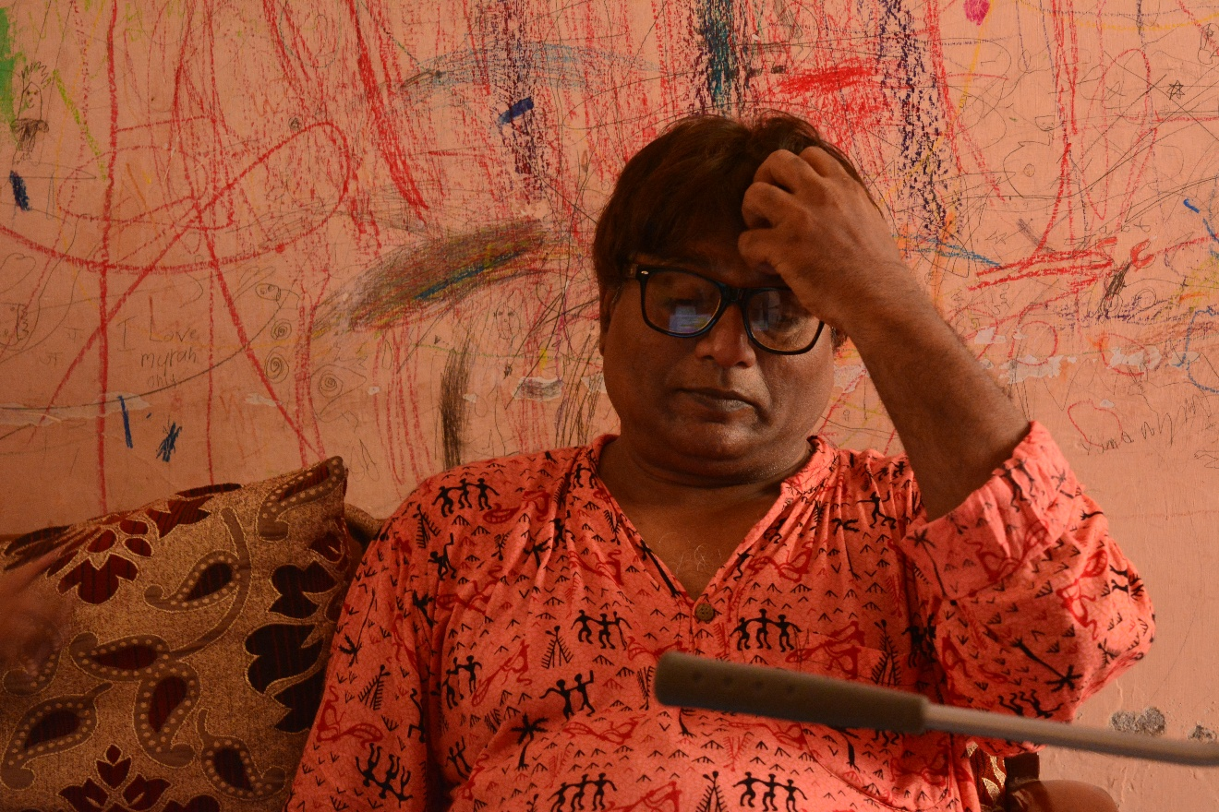
Director Shrivas Nydu

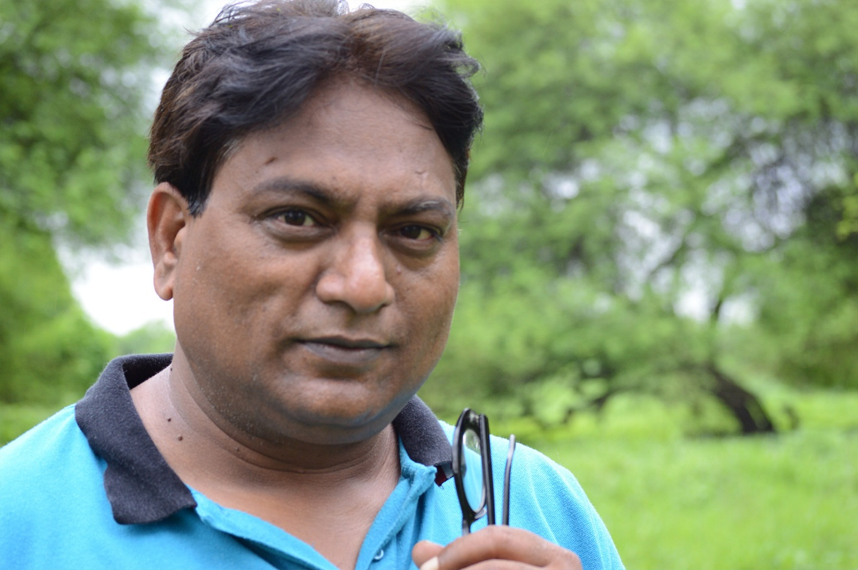
Director Shrivas Nydu

Screenshots
Seth Ardisher Irani, the man who pioneered talkie and colour film to India. Character played by Ravi Buley. A scene shot from the short - Manto's Marriage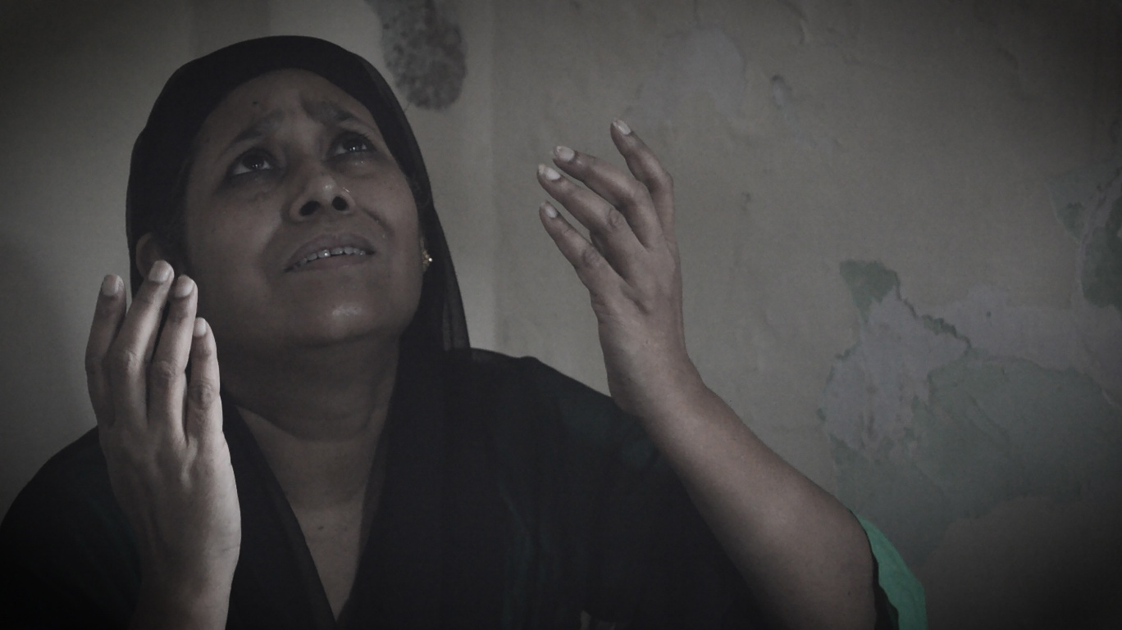
Mother of Manto who arrange a match for him. Cast – Sanchaita Rao Rana. A shot from the film - Manto's Marriage.

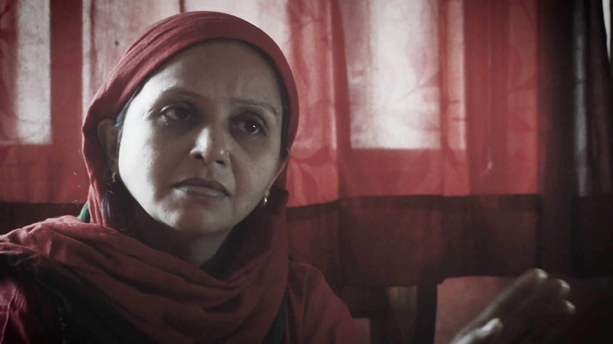
Khalajaan, Manto's Mother in Law played by Sonali Buley. A screenshot from - 'Manto's Marriage'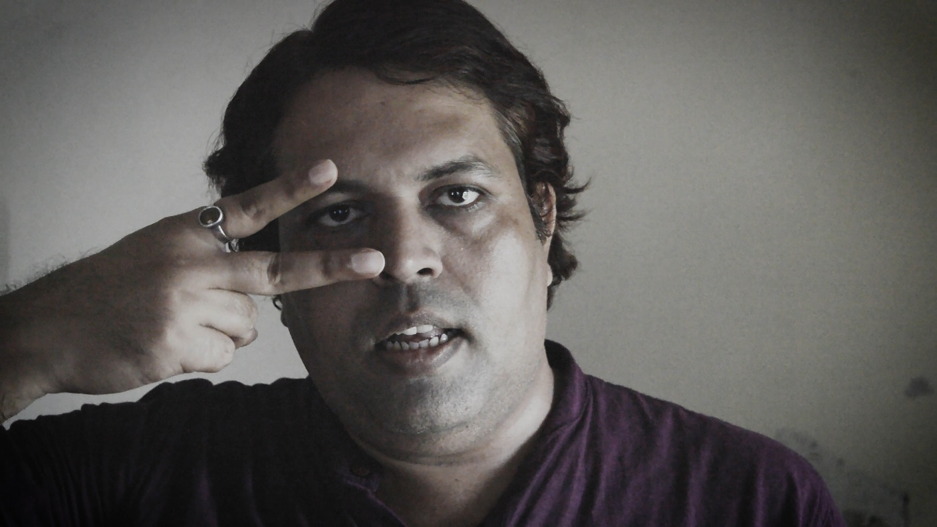
Mr. Ashiq a dance master from Bollywood of 1930s. Cast – Manoj Mishra. A screenshot from the short - Manto's Marriage

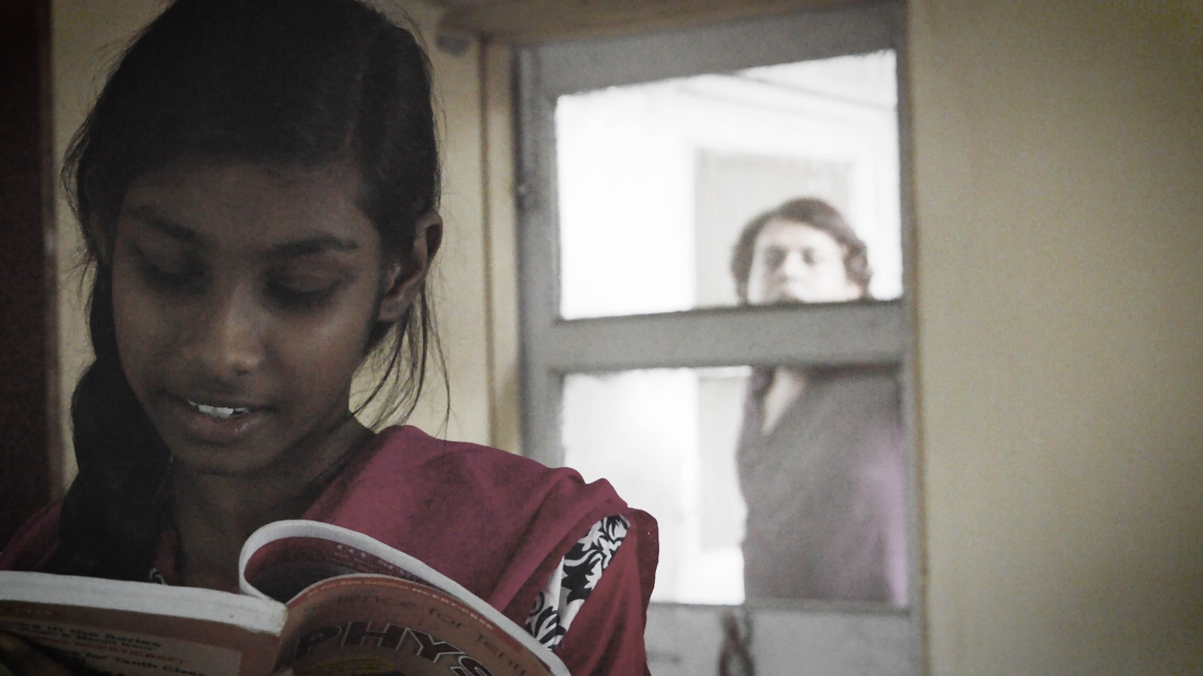
Dance Master Ashiq's follower played by Prerna Rana. A screenshot from the short - Manto's Marriage.
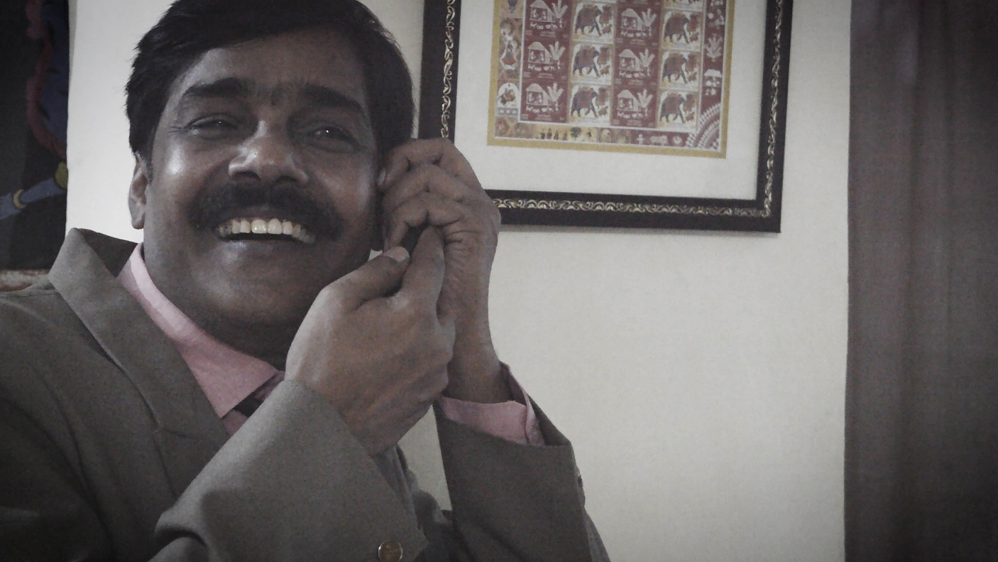
Nanu Bhai Desai, another Bollywood film producer of 1930s. Cast Sohan Rana. A screenshot from the film – Manto’s Marriage.

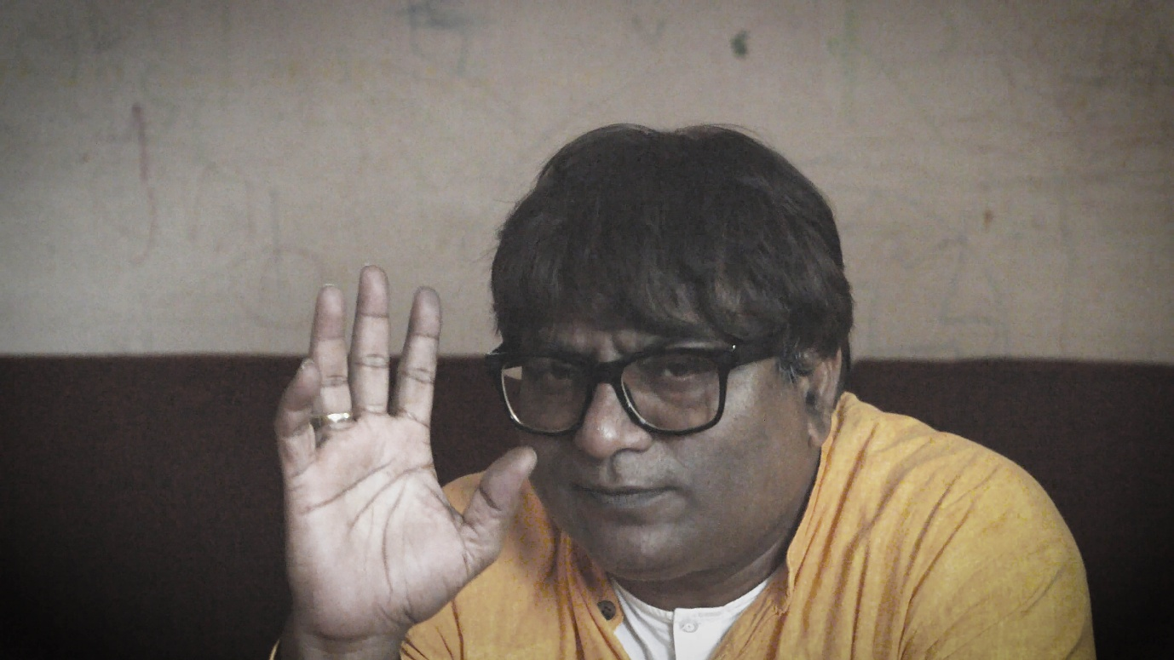
Saadat Hasan Manto, a great litterateur from Urdu Language played by Shrivas Nydu. A shot from the short - 'Manto's Marriage'.

