–
Synopsis

Lifelong friends Ibrahim and Abd Elnaeem, who move from South Egypt to Cairo to work as builders. Both sharing a small room and splitting the rent with a new joiner named Saleh who wishes to befriend them, the pair soon fight over payment disputes, which quickly escalates, as Ibrahim suddenly finds himself killing his old companion. Unable to cope with the violent episode, Saleh abandons the apartment, leaving Ibrahim by himself. Haunted by his brutal actions, Ibrahim has sinister hallucinations that Abd Elnaeem is still present in the claustrophobic room.

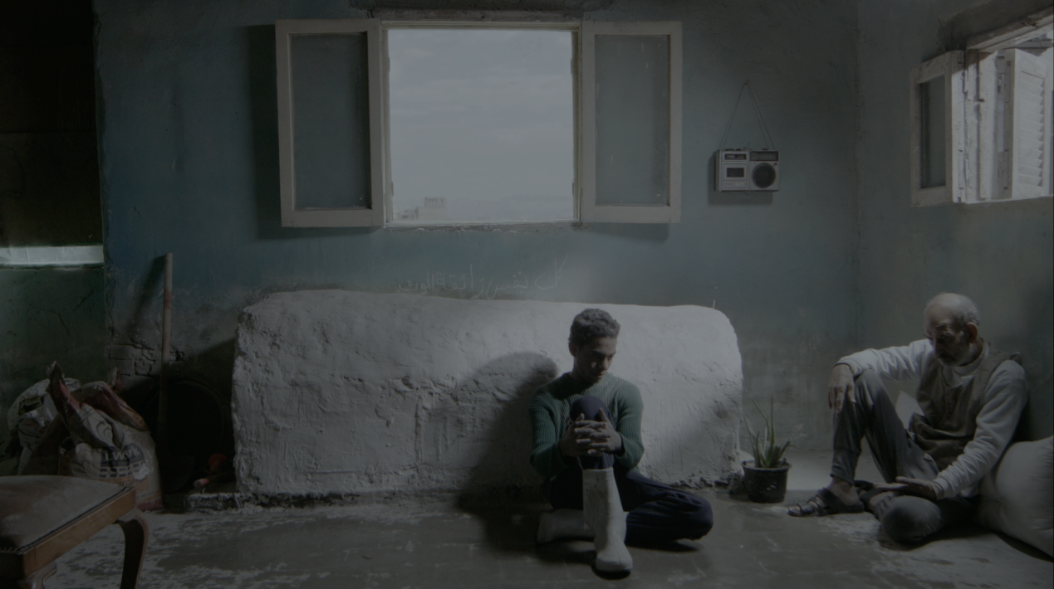

Naji Ismail

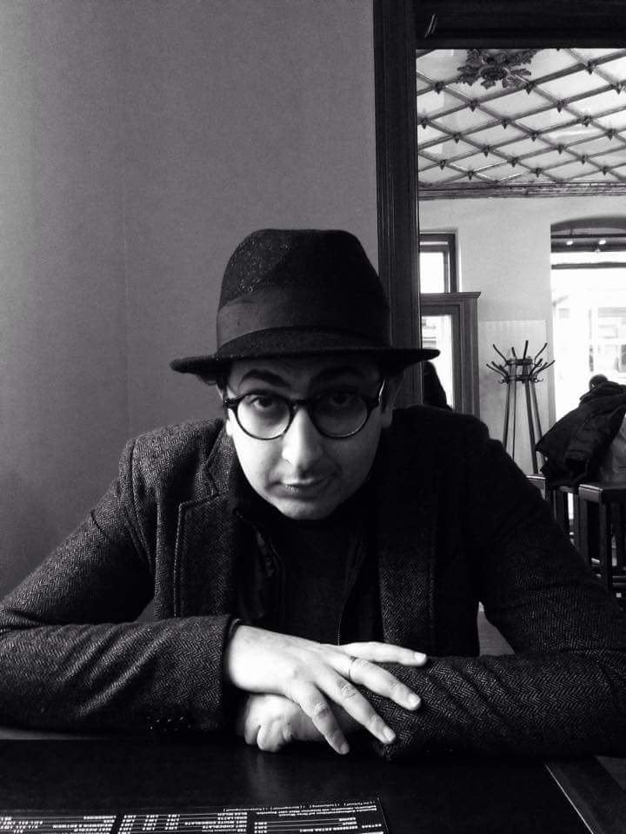
Naji Ismail was born in 1983 in Ain Shams, Cairo. He graduated from the Higher Cinema Institute on 2006 from the Directing department. During these 5 school years he filmed 2 short feature films (35 mm).

After his graduation he participated in several workshops:
- Workshop with the Danish Film School in 2007 and Multi-camera system.
- Basics of documentary films in 2008 (program by the EU.
- A workshop in Lebanon with Beirut DC in 2009 on how to develop a marketing portfolio for your film.
- Hotdocs workshop that was held in Syria in 2009
- In 2010 he was selected among 20 directors by George Washington University for a scholarship on how to make a documentary.

In the second half of 2012 he founded “Rahala for Production and Distribution”.

Filmography

The village, short fiction, graduation project, 35 mm film, 2005.
To cut it short, short fiction, graduation project, 35 mm film, 2006.
171, short documentary, digital.
Best Editing Award – 4eme Rencontres de l'Image – Centre Français de Culture & Coopération, Cairo, 2008.
Go kiss her, Short documentary, digital, 2010.
OM AMIRA, short documentary, digital
Berlinale short film competition 2014
Best cinematography for short documentary - SIMA 2014
ACT prize -ISMAILIA International film festival, 2014.
Best documentary BBC Arabic ANN KORB – 2014
Jury prize 4th Africa film festival – 2014
Best documentary 18th Egyptian National Film Festival – 2014
The builders, short fiction, digital, 2016.
Film data

Original film title: Elbananwa
English title: The builders
Directed by: Naji Ismail
Country of production: Egypt
Year of Completion: 2017
Exact length (hh:mm:ss): 00:18:20
Screening format: DCP/Blu-Ray
Shooting format: Digital/ Black Magic Camera 2.6K
Aspect ratio: 16:9
Color or B/W: Color
Spoken language: Arabic
Subtitles: English
Category: Fiction

Screenings

Official selection, Dubai International Film Festival (DIFF), 2016.
Official selection, Luxor African Film festival (LAFF), 2017.
Awards
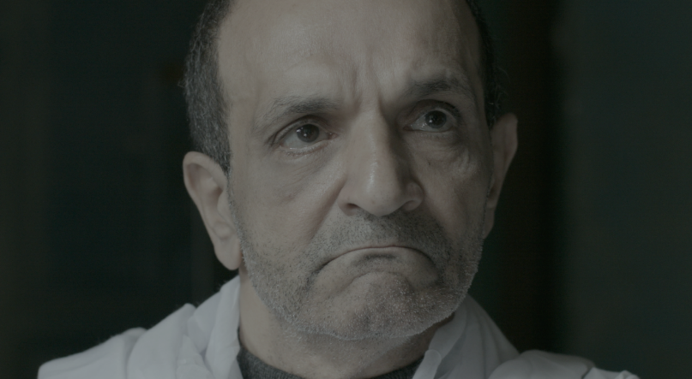

Radwan El- Kashef Prize for best film reflecting African issues, LAFF 2017.
Jury special mention, LAFF 2017.

Crew

Director: Naji Ismail
D.O.P: Mahmoud Lotfy
Art Director: Asem Ali
Producer: Naji Ismail and Shady Ishak
Story by: Naji Ismail
Screenplay: Naji Ismail
Cast: Mahmoud Gomaa, Saleh Abuzaid, Khaled El Fishawy and Fadel El Garhy
Editor: Kamal El Malakh
Coloring: Ahmed Abo El Fadl
Sound engineering: Bassam Farahat & Muslim El Houssieny
Sound design & Sound Mixing: Sama Abdu Elhady

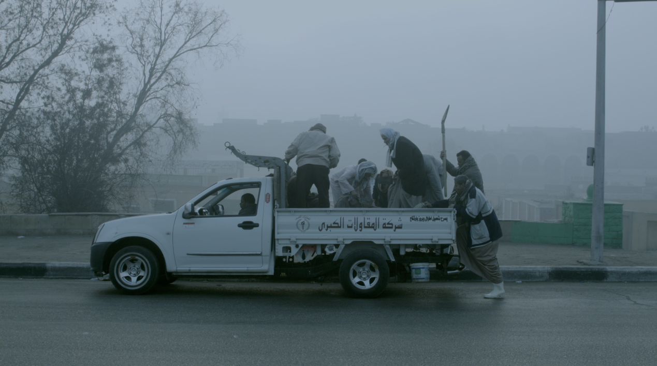

Production Company

Rahala Production and Distribution
RAHALA seeks to have a leading role in the independent filmmaking industry through working with young filmmakers who have the talent and passion to turn their ideas into films that are bold and creative. We are eager to work on and co-produce films not only from Egypt but also from around the globe, especially the rest of Africa.
RAHALA believes that a lower budget should not affect the quality of a film. They offer a professional production cycle from a film’s inception to its release, while guaranteeing filmmakers the space to make fresh and innovative films.

RAHALA believes in social responsibility and that art should be shared with everyone. That is why they aim to cooperate with other entities to offer filmmaking workshops and seminars in Egypt’s rural and informal areas.

In 2014, RAHALA's first short documentary "Om Amira" was selected in Berlinale competition. Also, the documentary won several awards such as first place award in the National Festival of the Egyptian Cinema 2014, Aan Korb: BBC Arabic Film and Documentary Festival 2014 and others.
In 2016, Rahala produced the short fiction "Fathy doesn't live here anymore" for the director Maged Nader. The film Participated in Berlinale forum expanded 2016, Durban Film festival 2016 and Sao Paulo Short Film festival 2016.
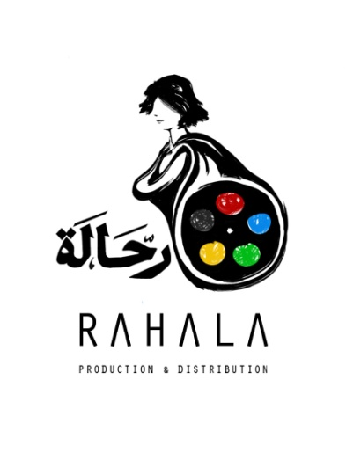
Produced by

Naji Ismail
Shady Ishak
For contact

Rahala Production & Distribution
Website: www.rahalaproduction.com
E-mail: rahalapro@hotmail.com / rahalaprojects@hotmail.com
Facebook: www.facebook.com/pages/Rahala -Production -Distribution
Phone: +201286986983

