Venice International Film Festival

Official Selection | Orizzonti | Short Film Competition

OFFICIAL SCREENING
FRIDAY, SEPTEMBER 8 - h. 5:00 PM |SALA GIARDINO

LA CASA DEI SANTI
in cooperation with RECALCATI MULTIMEDIA

presents

“L’OMBRA DELLA SPOSA”
The Shadow of the Bride
a short film by Alessandra Pescetta

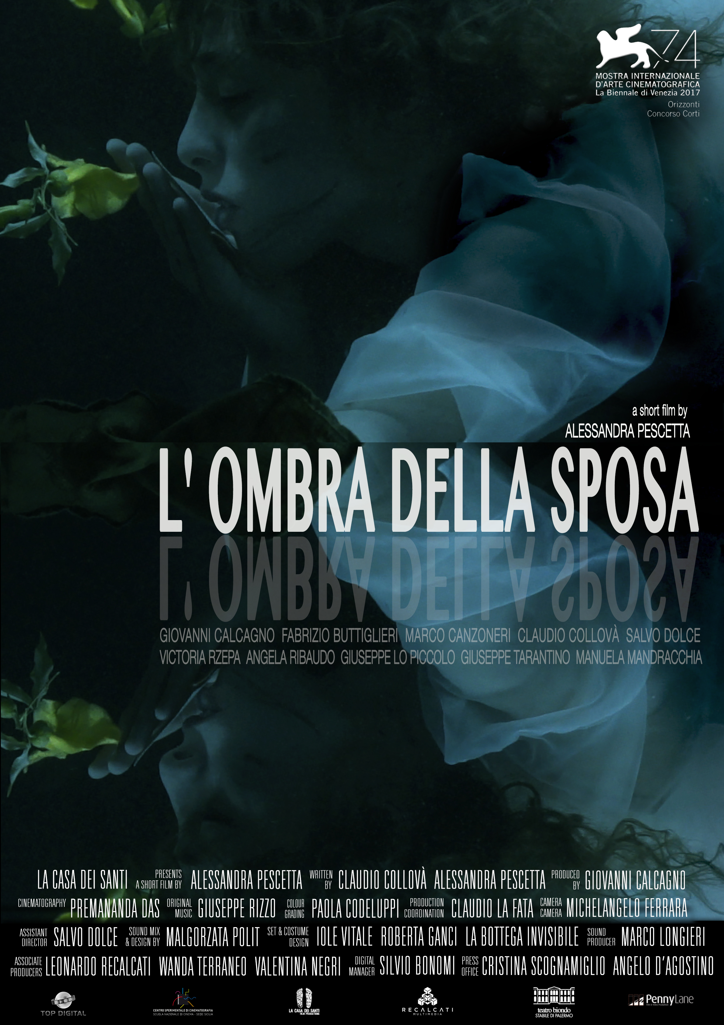

press office: promozione&comunicazione - Cristina Scognamillo
email: cristinascognamillo@hotmail.com | mobile +39 335 294961

SYNOPSIS

The last moments of life of WW2 soldiers are dissolved in the depth of the Mediterranean Sea, among emotions and thoughts. While sinking inexorably in the fascinating and cruel sea, love echoes in the letters of a husband soldier to his spouse. Today we can still hear those cries arise from the sea.

“There’s always a red sea, a living or dead sea that appears in front of all wandering men in search of a home.” Stefano D’Arrigo, Horcynus Orca.

DIRECTOR’S NOTE

What’s the last thought of a dying man? The image of a boat the crosses the Messina Strait during WW2, cutting through a sea full of dead bodies, can perhaps offer us a possible answer. With this short film, we sunk in the depths of the water to recall the horror the sea can hide.

During WW2, thousands of soldiers and marines lost their lives in the Sicilian sea. This film is dedicated to those boys buried in the sea.

CAST

Giovanni Calcagno Sailor
Angela Ribaudo Spouse

Marco Canzoneri Soldier
Claudio Collovà Soldier
Salvo Dolce Soldier
Giuseppe Lo Piccolo Soldier
Giuseppe Tarantino Soldier
Victoria Rzepa The Sea Girl

Narrators:
Manuela Mandracchia Spouse
Giovanni Calcagno Sailor
Claudio Collovà Soldier
Salvo Dolce Soldier

CREW

Director and Screenplay Alessandra Pescetta
Screenplay Claudio Collovà, Alessandra Pescetta
Text Claudio Collovà
Cinematography Premananda Das
Music and sound design Giuseppe Rizzo
Editing by Alessandra Pescetta
Production and costume designer Iole Vitale, Roberta Ganci, La Bottega dell’invisibile
First Assistant Director Salvo Dolce
Production Assistant Claudio La Fata
Studio & Mix Sound Engineer Malgorzata Polit
Assistant Cinematography Michelangelo Ferrara (CSC Palermo)
Post-Production Sound Top Digital- Marco Longieri
DCP & Digital Manager Silvio Bonomi
Promotion Manager Angelo D’Agostino
Translations into English Richard McKenna

Production La casa dei Santi
Producers Alessandra Pescetta, Giovanni Calcagno
Associated Producers Leonardo Recalcati, Wanda Terraneo,
Valentina Negri for Recalcati Multimedia srl
Origin ITALY
Year of production 2017
Length 11’

This short film was realized with the support of Teatro Biondo Stabile of Palermo, Centro Sperimentale di Cinematografia-Palermo, Top Digital Milan

Biofilmography

Born in Isola della Scala on July 13, 1966, Alessandra graduated in Painting at the Accademia di Belle Arti of Venice. She directed many music videos for renowned Italian (Ligabue, Elisa, Elio e le Storie tese, Subsonica) and International Artists like Planet Funk, and commercials for world known Italian brands like Campari, Bulgari, Valentino, Disaronno). Alessandra is a professor at Centro Sperimentale di Milano and since 2004, she coordinates the artistic company La casa dei santi with Giovanni Calcagno, producing and directing films, theater plays and art videos.

Her debut feature film “La Città Senza Notte” was selected worldwide in 2015 and achieved numerous acknowledgments and awards, among which Best Narrative Feature Film at the Sydney World Film Festival, the Gilda Award for Best Actress (Maya Murofushi) and the Seal of Peace Award at the International Festival of Cinema and Women - Life & Cinema; as well as the 2017 Great Special Jury Award at the Gallio Film Festival in Italy.

After finishing “the Shadow of the Bride”, which premiered in the Orizzonti Section of the 74th Mostra Internazionale del Cinema di Venezia, Alessandra started the pre-production of her second feature film, “100 Preludi”, produced by Recalcati Multimedia.

SELECTED FILMOGRAPHY (Cinema)

Feature Films
La Città Senza Notte (2015)

Short Films
L’ombra della sposa (2017)
Ahlem (2014)
Importante, molto importante (2013)
Guarda le stelle (2009)
Il santo del giorno (2004)
Homotaurilia (2001)
Ti ricordi di Fox? (2000)

Art Videos / Experimental
Qualcosa di simile (2012)
Sakura (2011)
Medea (2007)
La Pizia (2006)
La festa delle rose (2005)
Innaturale (1994)

Full Biofilmography (Commercials & Music Videos)
MUSIC VIDEOS

ORK, Till the sunrise comes (2017)
Planet Funk, Gli Uccelli (2004)
Subsonica, Liberi Tutti (1999) La Crus, Un giorno in più (1999)
Marina Rei, Un inverno da baciare (1999)
Negrita, Mamma Mae (1999)
Enrico Ruggeri and Andrea Mirò, Anna e il freddo che ha (1999)
Luciano Ligabue, L’odore del sesso (1999)
Luciano Ligabue, Metti in circolo il tuo amore (1999)
Elisa, Gift (1999)
Avion Travel, Dormi e sogna (1998)
Najwa Karam, Magroumy (1998)
Gemelli Diversi, Un attimo ancora (1998)
99 Posse, Quello che (1998)
Elisa, Cure me (1998)
Articolo 31, La rinascita (1998)
Elisa, A feast for me (1998)
Alexia, Number One (1998)
Luciano Ligabue, Il giorno di dolore (1997)
99 Posse, Non c’è tempo (1996)
Luciano Ligabue, Leggero (1996)
Elio e le storie tese, Noi siamo i giovani con i blue jeans (1993)
Timoria, Sangue impazzito (1993) (co-directed with Alessandro Orlowsky)
Best Music Video Award at MEI (Italian Yearly Meeting of Independent Labels)

COMMERCIALS
Valentino, Intrigate (2013)
Moscow Chips, Disco (2013)
Carioca Cafè, dance (2013)
Beretta viva la mamma, Colleghi (2011)
Parmigiano Reggiano, con Giuliano Razzoli (2010)
Grissinbon, con Caroline Kostner (2010) Mediastar Award for Best Directing
Don Cafè, The Obsession (2009)
Disaronno Momenti che contano davvero (2007)
Seat Leon, Fingers (2007)
Muller, Creme de creme (2007)
Grissinbon, Alice con Carolina Kostner (2006)
Cinzano Soda, Centauro (2006)
Haagen Dasz Bath (2006)
Ass. Forum Crisalide, Reverse (2005) Bronze Lion at the 52nd Cannes Advertising Festival
Divani & Divani By Natuzzi, Java Domino (2005)
Exuberance, Dtc (2005)
Protezione Civile, Close-Up (2004)
Morellato, Mirror (2004)
Alfa Romeo, Sun (2003)
Bvulgari, Eau Blanche (2003)
Campari Mixx, Mixed World (2003) Director of the Year, Italian Festival of Business Communication
Tissot, Bride (2003)
Lancia Y, Jewel (1999)
Seat Cordoba, Happy Nightmare (1999)
Campari Soda, Exchange (1999)
Fratelli dell’uomo, Tears (1999)

Full Biofilmography (Cinema)
FEATURE FILMS

La città senza notte (2015) Italy/UK, 89min, Drama
Screenplay by Alessandra Pescetta and Giovanni Calcagno

Freely based upon the short story “La pace di chi ha sete e sta per bere” by Francesca Scotti
Cast: Giovanni Calcagno and Maya Murofushi
Produced by: La casa dei santi and RareNoise Records Ltd
US Distribution: SMG Shami Media Group (USA)

International Film Festivals:
2017 Galio Film Festival (Italy), Special Grand Prize of the Jury
2016 New York World Film Festival (USA), International Competition
2016 Toronto Arthouse Film Festival (Canada), International Narrative Feature Film
2016 Lago Film Fest (Italy), Best Original Sound Track Nomination
2016 Ad Arte Calcata TeatroCine Festival, Panorama
2016 Isola del Cinema Film Festival (Italy), Special Weeks Program
2016 Ad Arte Calcata Teatro Cine Festival (Italy), Panorama
2016 Festival del Cinema di Frontiera (Italy), Special event: Lampi sul Mediterraneo
2016 Other Movie Lugano Film Festival (Switzerland), “Il trapasso dell’anima”
2016 Sguardi Altrove International Women’s Film Festival (Italy), Nuovi Sguardi
2015 Sydney World Film Festival (Australia), Best Narrative Feature Film Award
2015 Cork Film Festival (Ireland), Spirit of the Festival Award Nomination
2015 Cinema & Donne Film Festival (Italy)
Seal of Peace Award for Best Film, Gilda Award for Best Actress
2015 Parma Operart (Italy), Official Competition
2015 Ortigia Film Festival (Italy), 1915-2015 #NoWar 100 years from the great war
2015 Taormina Film Festival (Italy), Official Premiere, Only Italian Film in Competition

SHORT FILMS

L’Ombra della Sposa
(Short film/Fiction/Drama (HD, 11 min, 2017)
Screenplay by Alessandra Pescetta, Claudio Collovà
Cast: Giovanni Calcagno, Marco Canzoneri, Claudio Collovà, Salvo Dolce, Giuseppe Lo Piccolo, Victoria Rzepa, Angela Ribaudo, Giuseppe Tarantino - Voice Over: Manuela Mandracchia
Produced by La casa dei santi in association with Recalcati Multimedia

2018 Toronto Contemporary Italian Film Festival (Canada)
2018 From Venice to Moscow - The Italian Selection of the 74th Venice Film Festival (Russia)
2018 Film des Femmes de Créteil (France)
2018 Akbank Film Festival (Turkey), Perspective Section
2017 Festival di Cinema e Donne (Italy), Winner of Anna Magnani Award
2017 Mostra Internationale del Cinema di Venezia (Italy), Sezione Orizzonti, World Premiere

Full Biofilmography (Cinema)
SHORT FILMS (continued)

Ahlem (dreams)
Short film/Fiction/Drama (HD, 18 min, 2014)
Screenplay by Alessandra Pescetta, Francesca Scotti
Cast: Ahlem Benjeannette, Victoria Rzepa, Savì Manna
Produced by La casa dei santi and Fondazione per il sud
Distributed by Pacific Voice (Japan) and Gonella Productions (France)

2017 Festival Visages (Martigny, Switzerland)
2016 Salento Finibus Terrae (Conversano, Italy)
2016 Festival del Cinema di Frontiera (Marzamemi, Italy)
2016 Indie Crete Film Festival (Crete, Greece)
2016 Other Movie Film Festival (Lugano, Switzerland)
2016 Festival LAMPA in Cesis, Latvia
2016 Reel Sydney Festival of World Cinema (Sydney, Australia)
2016 Médiathèque Abdelmalek Sayad, Musée de l'histoire de France
2015 Youth Peace Int. Film Festival (Malang, Indonesia), Members of UNESCO
2015 Altern-Native IFF (Targu-Mures, Romania)
2015 Italian Nights (Istanbul, Turkey)
2015 Un Festival C’est Trop Court (Nice, France), Special Jury Award
2015 Rencontres Femmes Méditerranée (Marseille, France), Special Mention
2015 Le Temps Presse, Paris, France, Student Award section
2015 Vox Feminae Film Festival (Zagreb, Croatia)
2015 Russian Italian Film Festival (St. Petersburg, Russia)
2015 Women Media Arts & Film Festival (Sydney, Australia)
2015 Auburn Film Festival of Children & Youth (Auburn, Australia)
2015 2Annas Film Festival (Riga, Latvia)
2015 16Corto Film Festival (Forlì, Italy)
2015 One Country One Film (Apchat, France), Representative of Italy
2015 Nancy Lorraine Aye-Aye Film Festival (Nancy, France)
2015 Seoul International Youth Film Festival (Seoul, S. Korea)
2015 Corto di Sera Short Film Film Festival (Messina, Italy), Honorable Mention
2015 Riace in Festival of Migration and Local Cultures (Riace, Italy)
2015 A Corto di Donne Short Film Festival (Naples, Italy)
2015 River Film Festival (Padua, Italy), Best Italian Short Film
2015 European Days of Border Guards (Warsaw, Poland)
2015 Pazmany Short Film Festival (Pazmany, Hungary)
2015 Rome Independent Film Festival (Rome, Italy)
2015 Taos Shortz Film Festival (New Mexico, U.S.A.)
2015 Buff Malmoe Film Festival of Children & Youth (Malmoe, Sweden)
2015 Visioni Italiane (Bologna, Italy)
2015 Sguardi Altrove (Milan, Italy)
2015 Le Temps Presse (Paris, France), Student Award Selection
2014 Festival Tous-Courts (Aix-en-Provence, France)
2014 Oulu International Children's & Youth Film Festival (Oulu, Finland), Youth Competition
2014 Festival del Cinema dei Diritti Umani di Napoli (Naples, Italy)
2014 Flanders Film Festival (Gent, Belgium), World Premiere

Full Biofilmography (Cinema)
SHORT FILMS (continued)

Importante, molto importante
Short film/Fiction/Drama (HD, 12 min, 2013)
Produced by La casa dei santi
Based upon the theatrical play by Savi Manna
Cast: Ilenia Maccarrone and Savì Manna

2013 Genova Film Festival, Best Soundtrack
2013 Artelesia Film Festival, Best Soundtrack
2013 Non è mai troppo corto Best Cinematography & Best Actress
2013 XIII Festival Int. del Cinema di Frontiera, Best Actress
2013 Visioni Italiane, Best Short Film Visioni Isolane
2013 Gold Elephant World, Riflessi d’Arte Award
(Festival Internazionale di Cinema e Musical di Catania)
2013 Festival MovieValley Bazzacinema, Best Short Film
2013 A Corto Di Donne Special Mention for Best Fiction
2013 Fabriano Film Fest Best Short Film, Best Original Score, Eyes on the World Special Award

Qualcosa di Simile
(Short Film/Fiction/drammatico (HD, 15 min, 2012)
Produced by La casa dei santi
Based upon the homonymous book of short stories by Francesca Scotti

2013 Rassegna Sguardi Altrove, Spazio Oberdan Milano
2013 Sorsi Corti Film Festival Best Art Video
2012 Nonèmaitroppo Corto di Gravina Special Mention, Best Director, Best Cinematography
2012 Official Selection Corto di Donne
2012 Tolfa Film Festival, Experimental Section
2012 Imola Film Festival
2012 Corti Vivi Filmfest
2012 Preview at Taobuk, Taormina
2012 International Literature Festival

Guarda Le Stelle
(Short Film/Fiction, 2009)
Produced by La casa dei santi in collaboration with Rai Gulp & Zo Centro Culture Contemporanee
Aired by Raigulp on November 11th, 2009 on occasion of the Children’s Rights Anniversary

Homotaurilia
(Short Film/Fiction/Drama (s16, 20 min, 2001)
Produced by Altamarea film

2002 Festival Opere Nuove Bolzano
2002 Milano Film Festival
2002 Venice Circuito Off Special Mention for Best Director
2002 Valdarno Cinema Fedic
2002 Corto Potere
2002 I laghi di Marte Special Mention for Best Director
2002 TTV Festival

Full Biofilmography (Cinema)
SHORT FILMS (continued)

Ti ricordi di Fox?
(Short Film/Fiction/Drama (35mm, 20 min, 2000)
Produced by BRW & Partners

2003 Corti da Sogni, Best Director
2002 Braunschweig Film Festival
2002 TTV Festival
2001 Anteprimannozero
2001 Genova Film Festival
2001 Bellaria Festival of Imola

For Festival Promotion:

Angelo D’Agostino
Penny Lane Film
Wohllebengasse 18/6
1040 Vienna, Austria

angelo@pennylane-film.at
+43 650 8747 277

