CONVERSAZIONE PRIVATA
(I Will Survive)

a film by Mutombo

written by Nausicaa di Benedetto & Mutombo

with Ilaria Spera
Antonio D’Emilio
Fabrizio Eleuterio

produced and distributed by Antonio Genovese

https://www.facebook.com/ConversazionePrivataShortfilm/
https://www.instagram.com/conversazione_privata/

CREW

Director Mutombo
Screenplay Nausicaa di Benedetto & Mutombo
Cinematographer Angelo Coli
Production Designer Riccardo Frascarella
Casting Director Sara Vitale
Editor Cristina Di Lorito
Sound Designer Matteo Di Simone
Original Music Fabio D’Onofrio
Floor Sound Engineer Edgar Iacolenna
Make-up Elisa Guidotti
Costumes Designer Francesca Cilli

Executive Production Peperonitto Film

CAST

Ilaria Spera Jenny
Antonio D’Emilio Vince
Fabrizio Eleuterio Luca
Andrea Di Luigi Vince (Actor)

SPECIFICATIONS

Nationality Italian
Year of Production 2018
Lenght 20 minutes
Genre Drama-Sentimental
Aspect Ratio 2.35:1

SYNOPSIS

Jenny, a young actress and stage director, is about to debut with her first piece, a very personal text on the end of a troubled love story. Present and past, imagination and reality, will accompany Jenny during the play.

DIRECTOR BIO-FILMOGRAPHY

Antonio Genovese (aka Mutombo) was born in Italy in 1990. From the age of 20 he travels around the world until he returns to Italy in 2015 and starts a two-year course in a Film School.
In 2017 he made his first short film as writer and director, "Scala 6". It’s distributed by Premiere Film and obtains some selections and awards in Italian and International film festivals.
In May 2017 he works as First Assistant Director for the film "La porta sul buio", Marco Cassini’s second feature film.
In September 2017 he’s selected among the 20 finalists of the "Pitch in the day", a contest for feature scripts held in Rome, where he had the chance to present the project to 20 among the major Italian producers.
From the end of 2017 and throughout 2018 he’s engaged in the production of his second short film "Conversazione Privata (I Will Survive)" which also sees him as director and writer.
In April 2019 he’s selected among the 20 emerging directors from Europe and Middle East to take part in the “Go Short Campus 2019” during the “Go Short International Film Festival” in Nijmegen, Netherlands.

DIRECTOR’S STATEMENT

The idea behind the screenplay of "Conversazione Privata" (Private Conversation) comes from two different sources: the text of the famous song played by Gloria Gaynor, "I Will Survive", and the atmosphere evoked by an empty theater. Then, we start to write a story about a new beginning. A story in which the “hero”, Jenny, a young actress and stage director, is about to debut with her first piece: a very personal text on the end of a troubled love story. And thanks to this strenuous act of strength she will shake the burden of her past and start, finally and freely, to make choices on her present and future life.
While writing, we were increasingly aware on the universality of the story. Indeed, we are all affected by the negative experiences of our past, experiences that hold us back in our future choices. We are afraid of making mistakes again and we just give up, we don’t even try. Jenny shows us that, even if difficult, we must believe it and try it, always.
The story is very little autobiographical if not just for this feeling of risking, of trying, of not settling. When I was just over 20, in a moment of Utopian Romanticism, I decided, from then on, that I would’ve tried to do what I wanted, as I wanted and when I wanted. Surely it was not always like this, you also make compromises, but I enjoyed it when I acted that way, when I disregarded all prejudices and not considered all the obstacles before my goal. I hope this film, even if short, is able to convey this sensation.
The story of Jenny is an intimate and personal one, it could’ve been told in thousands of ways, but we decided to do it big; in fact, being a movie, we tried to spectacularize the emotions of the protagonist. For this reason, the moment of Jenny's new awareness doesn’t happen in a silent and isolated place with her immersed in her thoughts, but it happens in front of a full house theater who applaud to the success of her first play.
Finally, this film has also involved me as a producer, with enormous physical and economic sacrifices, and it involves me as a distributor too. In fact, I preferred not to rely on short film Distributor but to independently choose the strategy and the festivals to which I would send my work.
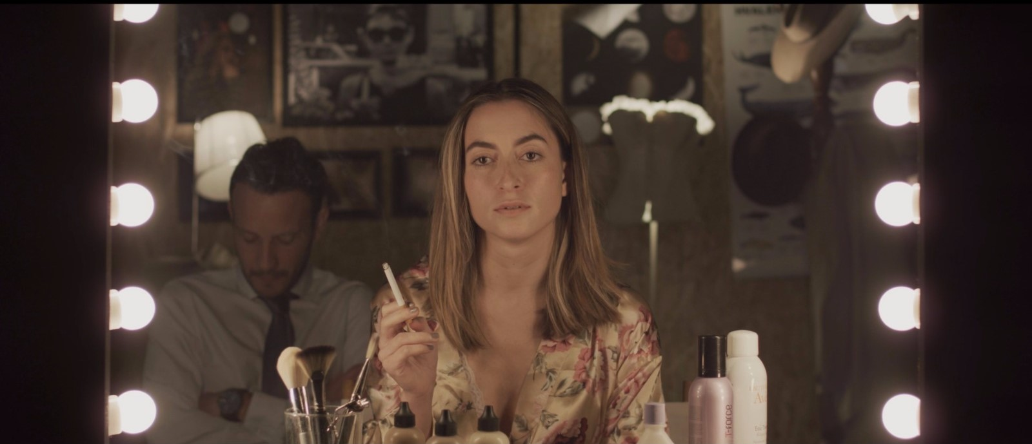

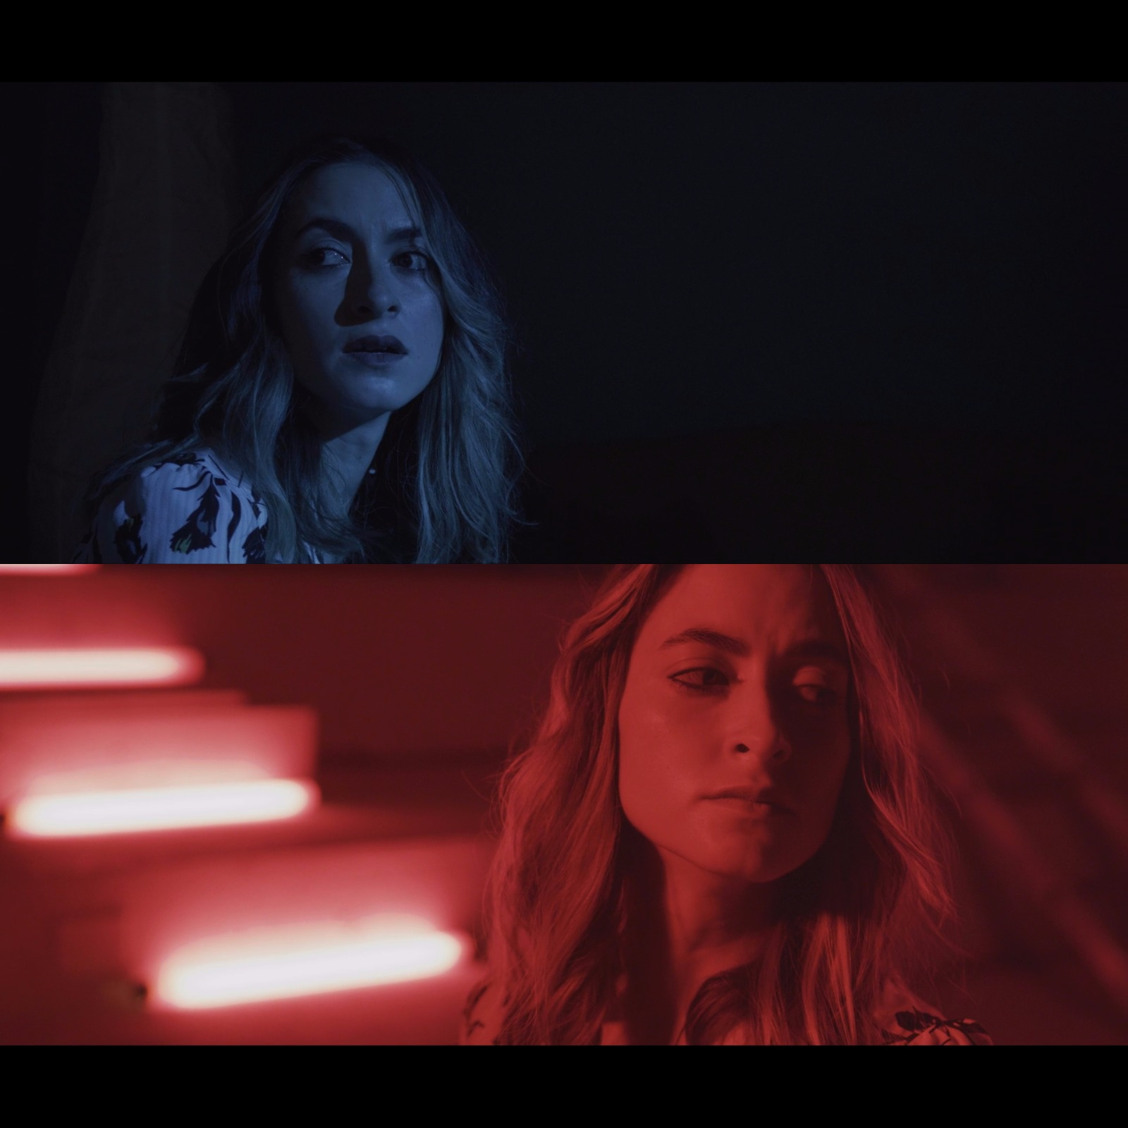

Contacts
Produced and Distributed by Antonio Genovese
(0039) 389 1306298
genoveseantonio@hotmail.it

