Shadows of Endurance
DOC Movie • 22 min 15 sec • History Completed 1st of Jul 2016

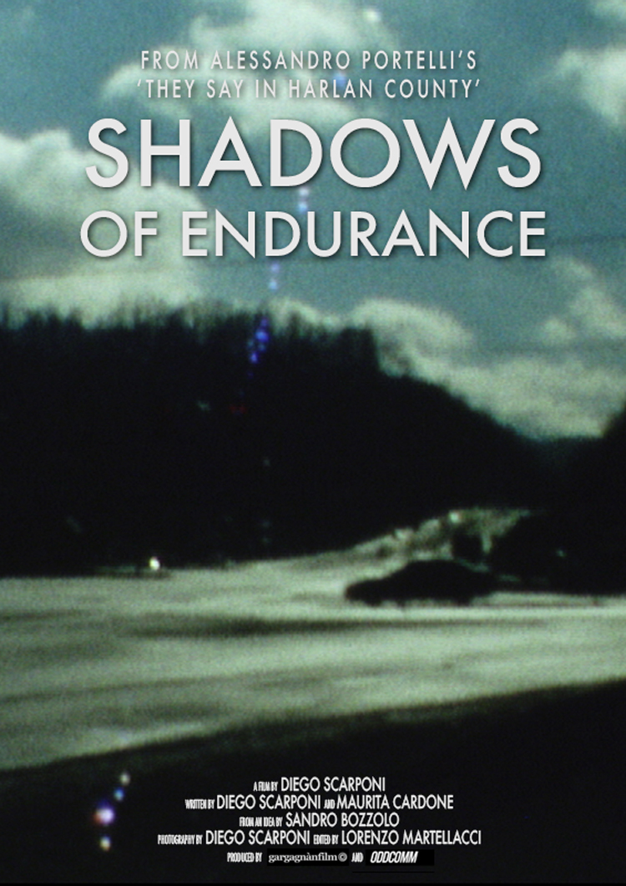

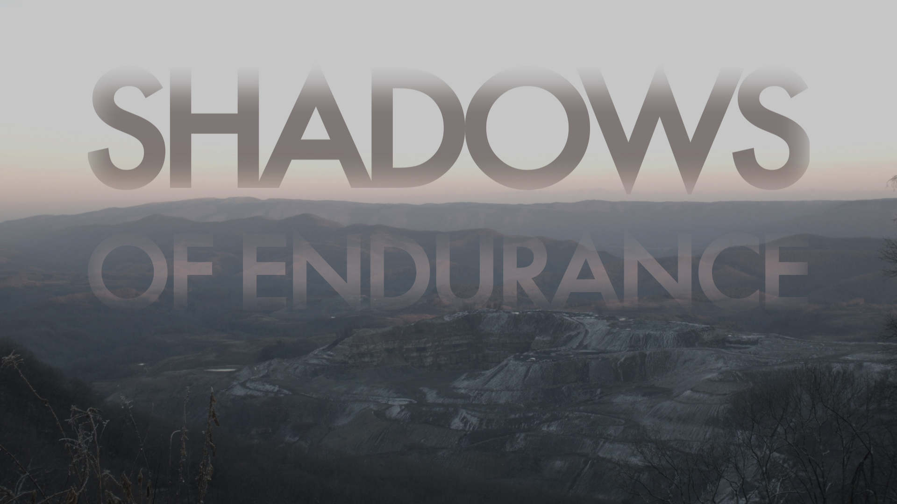

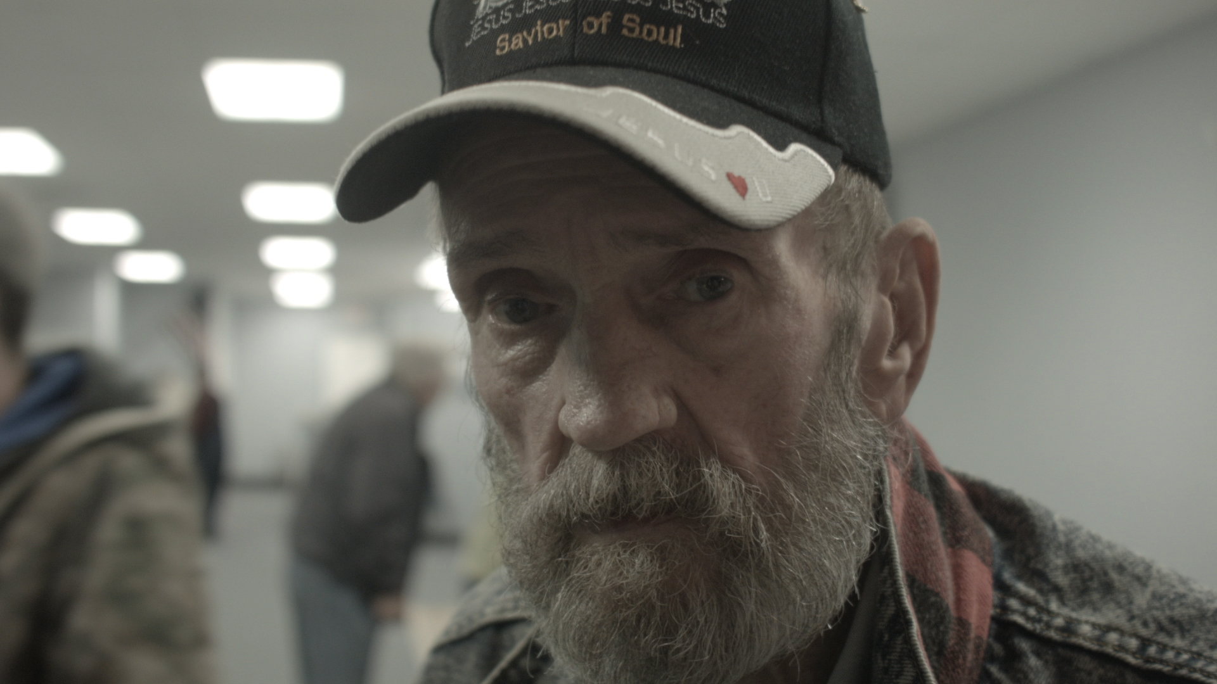

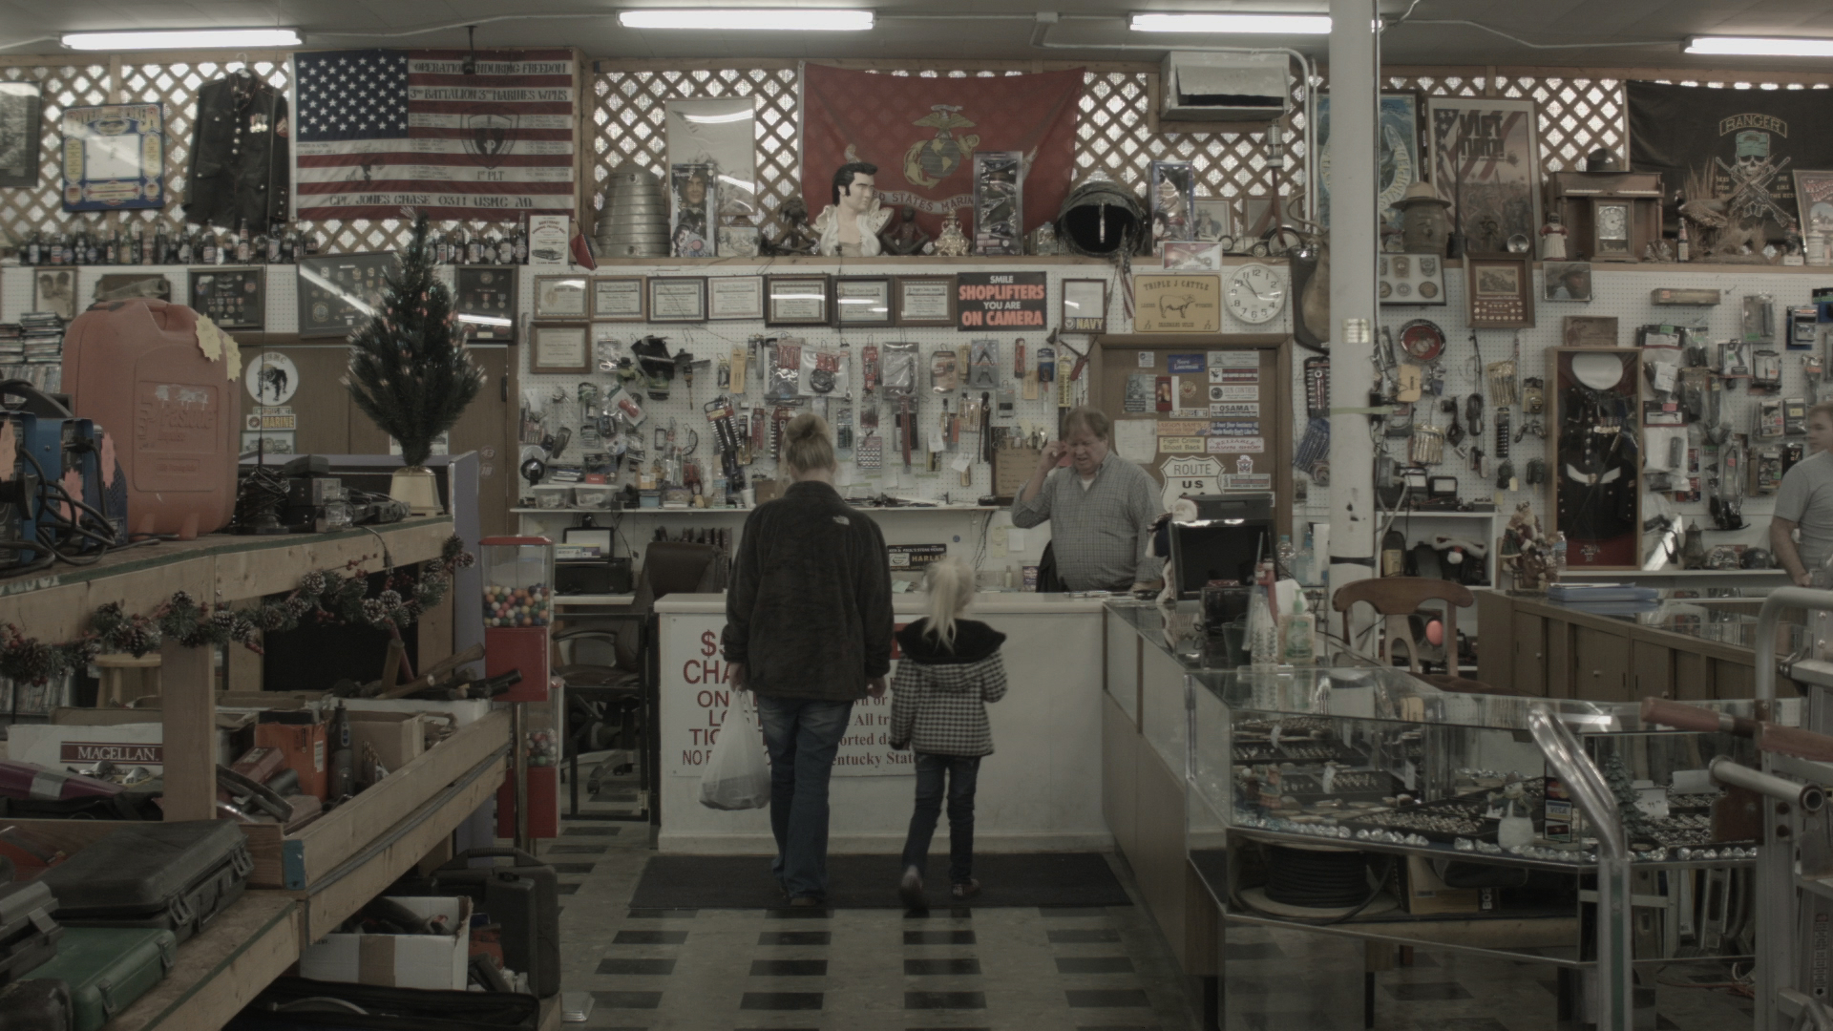

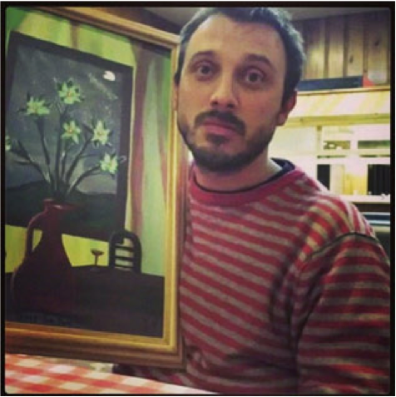

Long synopis
Shadows of Endurance portraits two centuries of American history through stratified layers of time, comparing the lives of the people currently living in Harlan County with the huge amount of oral histories collected and recorded by Italian author, Alessandro Portelli, over 30 years of field research. The film is a journey through different times, each with their ghosts and voices, as distant echo of a bygone age, re-emerging today in the places and faces explored by the camera.
Through a series of interviews, the film introduces to the stories of people struggling to survive in an area stripped of its identity. A sense of absence dominates the encounters with the characters who currently live in the area: a lack of work, relationships, future, and hope.
Deprived of a historical perspective as well as of any possible trajectory, these characters reveal a dramatic nature –often leading a life on the fringes of the law, fighting a lonely battle for survival. On the other hand, the testimonies gathered by Mr Portelli reflect a mythical and yet concrete past, when the clash was collective and the elements were supernatural.

Short synopsis
The film is the result of the intersection between a series of encounters with people that live in Harlan today and the voices from the past gathered by Alessandro Portelli. While the places are the same, the themes, though connected, are often in opposition. Today's Harlan is facing the crisis of the ming industry and, as a result, poverty, crime, social isolation, and drugs are on the rise. The people we met describe their everyday struggles while they seem unable to find alternatives. Excerpts from Alessandro Portelli's book “They Say in Harlan County. An Oral History” and some of the interviews he recoded in his field research, work as an introduction to the stories told in the film.

Short logline
Shadows of Endurance portraits two centuries of American history through stratified layers of time, comparing the lives of the people currently living in Harlan County with the huge amount of oral histories collected and recorded by Italian author, Alessandro Portelli, over 30 years of field research.

Logline
Shadows of Endurance portraits two centuries of American history through stratified layers of time, comparing the lives of the people currently living in Harlan County with the huge amount of oral histories collected and recorded by Italian author, Alessandro Portelli, over 30 years of field research. The film is a journey through different times, each with their ghosts and voices, as distant echo of a bygone age, re-emerging today in the places and faces explored by the camera.
Through a series of interviews, the film introduces the viewer to the stories of people struggling to survive in an area stripped of its identity. A sense of absence dominates the encounters with the characters who currently live in the area: a lack of work, relationships, future, and hope.
Deprived of a historical perspective as well as of any possible trajectory, these characters reveal a dramatic nature –often leading a life on the fringes of the law, fighting a lonely battle for survival. On the other hand, the testimonies gathered by Mr Portelli reflect a mythical and yet concrete past, when the clash was collective and the elements were supernatural.

Details
FILM CATEGORY Documentary, Experimental, Short
PRODUCTION LOCATION U S A, Italy
FILMING LOCATION U S A
FINANCING 30000 USD
MAIN DIALOGUE LANGUAGE English

Biography for Diego Scarponi
Diego Scarponi works at the University of Genoa, where he directs the Audiovisual Laboratory “Buster Keaton” and conducts research with a focus on the traces of the industrial presence in urban environments and its role in the construction of contemporary identity.
He produced and directed numerous documentaries and cross-media projects.
“L'età del ferro” (The Iron Age, 2013) was among the finalists at the Viaemiliadocfest and participated in the Genova Film Festival and the Mantova Film Festival. With the short doc “Memoria fossile” (Fossil Memory, 2014) he was selected at the 12° TIFF, Tirana International Film Festival (November 2014). In 2015 he worked at “Ribelli e fuorilegge” (Rebels and Outlaws) and at “Alfabeto Camallo - Noi eravamo tutto” (Alfabeto Camallo – We were all).

Your Production Notes/Anecdotes
Back Then and Today
In the early Sixties, It was the powerful music from the Appalachian Mountains, with its songs of protest, that first caught the attention of young Italian scholar, Alessandro Portelli and drew him to Harlan County, Kentucky.
Captivated with in the untold stories of the people of Harlan County, over the next three decades Mr Portelli kept going back to Harlan interviewing dozens of people and recording everything on tape.
Through the synthesis between the images and voices of today and the priceless archive of recordings collected by Alessandro Portelli, Shadows of Endurance is a cinematic exploration of the obscure and forgotten sides of the American culture.
The expressive potential of the audio material, as well as the poetics of the contributions, and the symbolic power of the content allow a reinterpretation of those stories that brings back to the public the voices of the characters from an era that is now blurred.
The times of transformations are gone, and today Harlan looks like an empty container of the stories of the past. In this sense, our film stages a sort of "city of ghosts".

Statement of the Director
Portraying Harlan is portraying the United States: the sudden development of a region and its equally rapid de-industrialization are a concrete example of the dynamics of global capitalism, which here leave violently evident traces on the children and the grandchildren of the people interviewed by Mr Portelli. Harlan's coal was used to light up the cities on the coast, but the remains of all that energy is “white trash”, a derogatory expression that today is used to describe the poor whites who live in these areas, the direct heirs of the “hillbilies”, the term used to dub the Appalachians, the inhabitants of these areas.
Always hidden and despised, the people of Harlan today are constantly looking back at the past, seeking for their heroic roots, sharing with their predecessors the same need to resist and survive adversity. Endurance is a term that Portelli borrowed from Faulkner and that embodies the very spirit of the work we have undertaken.

Screening file SUB ENG
Title SHADOWS OF ENDURANCE [SUB ENG]

Url: https://vimeo.com/172537464
Password: SHADOWSENGSUBENG

Screening file SUB ITA
Title SHADOWS OF ENDURANCE [SUB ITA]

Url: https://vimeo.com/167285534
Password: SHADOWSENGSUBITA

Short Trailer (SUB ENG)
https://vimeo.com/178169827

Trailer (SUB ENG)
https://vimeo.com/172574557

Trailer (SUB ITA)
https://vimeo.com/178185009

FESTIVAL SELECTION
Asiana 2016 [AISFF 15] - Seoul (South Korea)

Website
http://www.gargagnan.net/

facebook
https://www.facebook.com/gargagnanfilm/

twitter
https://twitter.com/gargagnanfilm

