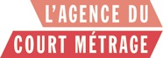

Max et ses filles
A short film directed by Delphine Berger

Written by Tonie Behar and Delphine Berger
From the novel of Tonie Behar « Grands boulevards » (éd. Jean-Claude Lattès)

Synopsis : It was always a bit complicated between Doria and her sister Alice! And on the evening of their father's birthday Max, the two sisters finally spoke out and all that was never said finally came out on the table!

Avec Lila Salet, François Berland, Lilou Fogli,
Lionel Cecilio, Gabrielle Lazure, Stéphane Giletta

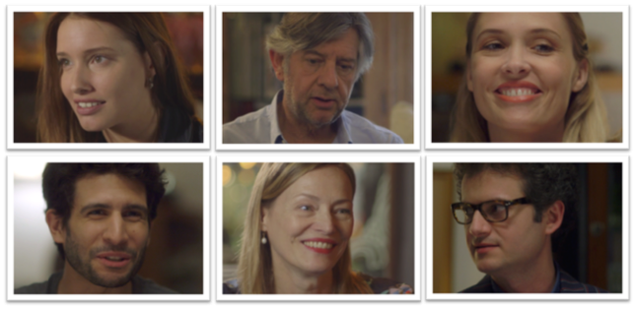

For Doria, a pretty 28 years old actress, life is sometimes complicated. Always looking for the good part, always attracted by the wrong guy, she has difficulties to stabilize!
The evening of her father's birthday, Max, is the occasion for a family gathering. The relations between her sister, Alice and Doria have always been complicated. Why? That evening between two swigs of whiskey, the 2 sisters got everything off their chests! And all that was never said finally came out on the table. Doria’s mother, Sophie will also have to give some explanations.

How this short film is born ?
Tonie Behar remenbered : «One day, Delphine called me, very excited and told me "I thought, we need to make a short film with your novel".» I said "OK!" Three months later, our film was written, shot and edited. "
Delphine Berger works on a famous TV show and Tonie Behar is novelist. They met in a contemporary way, via Facebook. A few messages and a drink later, they decided to work together. Max's daughters is their first common achievement but not the last one !

Cast:
Lila Salet DORIA
Lilou FOGLI ALICE
François Berland MAX
Gabrielle Lazure SOPHIE - DORIA'S MOTHER
Lionel Cecilio FRED, DORIA' BOYFRIEND
Stephane Giletta ERIC, ALICE'S HUSBAND

Crew:
Delphine Berger and Tonie Behar: Writers

Tonie Behar, novelist, writer and blogger.
Author of four novels - including « Grands boulevards » - published at JC Lattès Edition.
Specialist of the rom-com, she created the blog comedieromantique.com, and founded the #TeamRomCom. She is currently preparing his 5th novel.

Delphine Berger, scénariste – réalisatrice.
Before writing and directing « Max’s daughters », I developed several projects of feature films including "Fasten your seatbelts" for which I shot sequences to produce a teaser.
I have extensive experience filming and post-production, as a fiction and television script supervisor. Indeed, I practiced this profession with many directors for 17 years, particularly on the fiction of the "Guignols de l’info". A really good training where I was able to participate actively in all the stages of Production : shooting and editing particularly.

Nicolas Beauchamp : Director of Photography
Fabrice Aboulker : Music composer
Alice Duval : Editor

Production:
France
Del Films
Delphine Berger Producer

Technical Details :
PICTURE FORMAT Color
ASPECT RATIO 1.77
SHOOTING FORMAT HDV
EXHIBITION FORMAT DCP

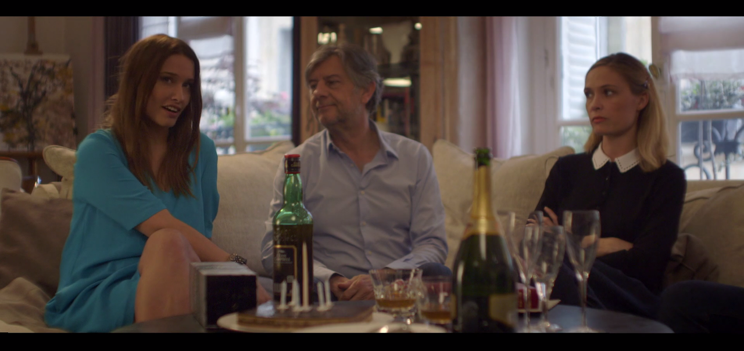

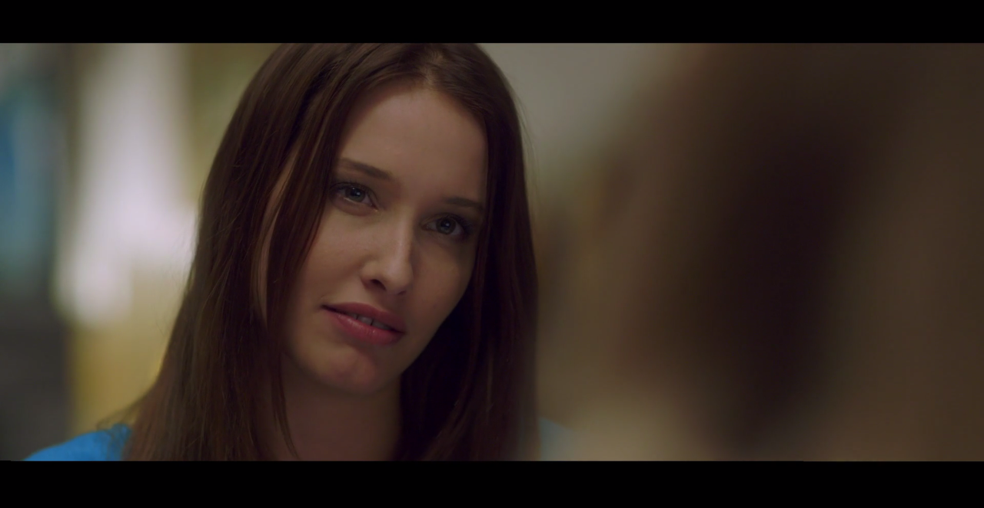
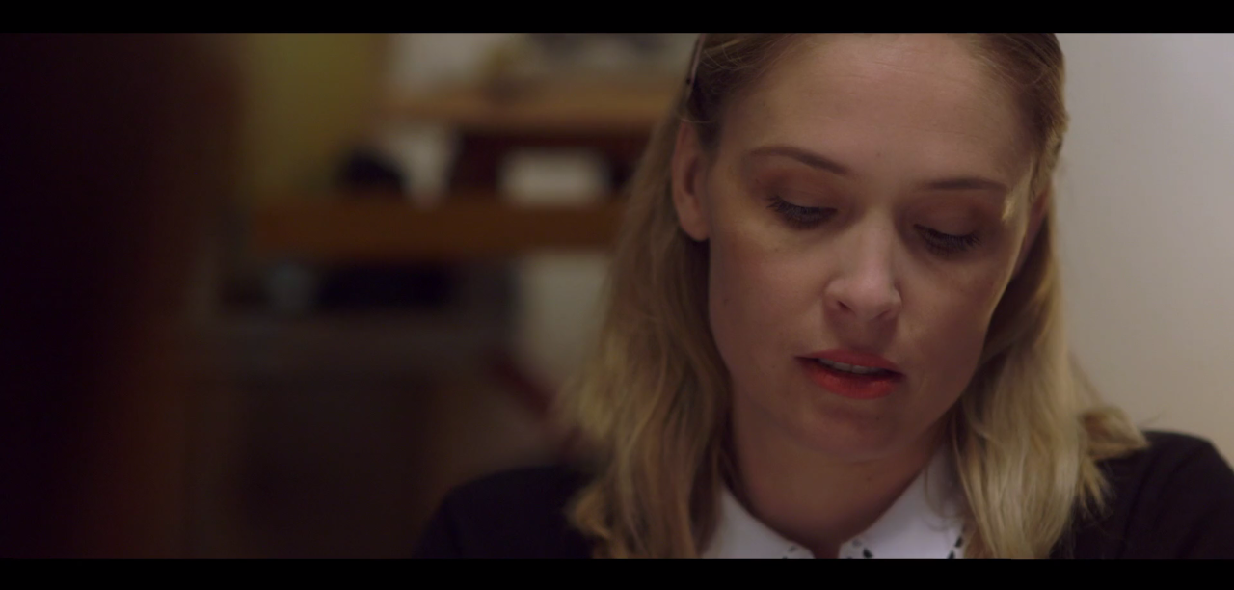

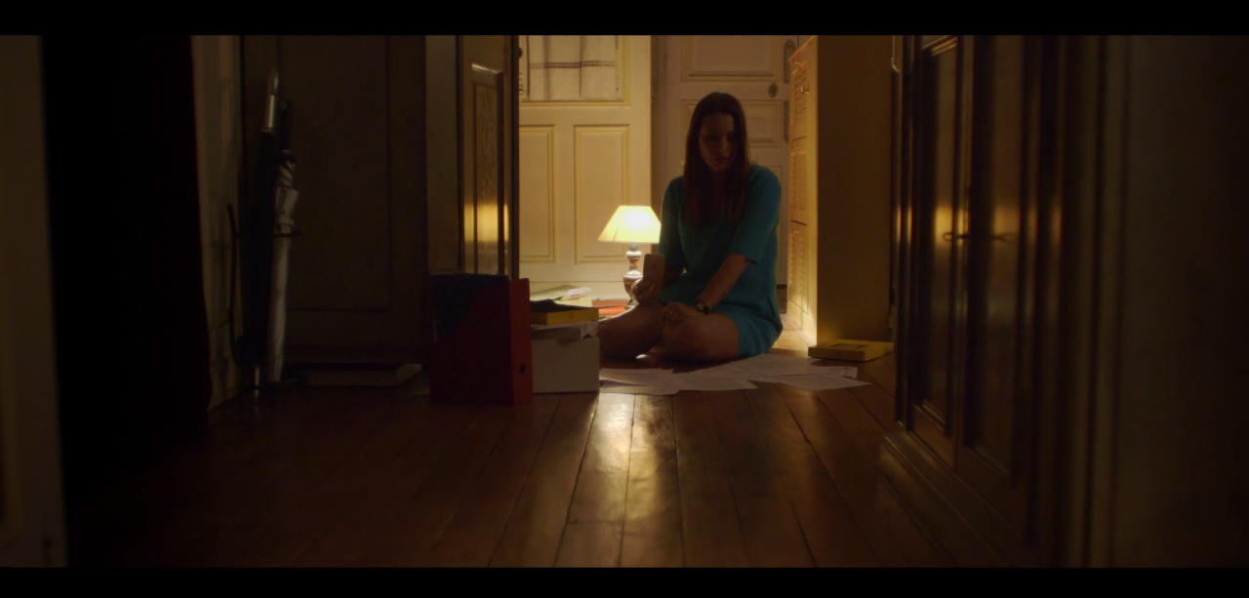

Contact : DEL FILMS - Delphine Berger – 0660172158 - d.berger@delfilms.com

