PLUMES BLANCHES PRESS KIT

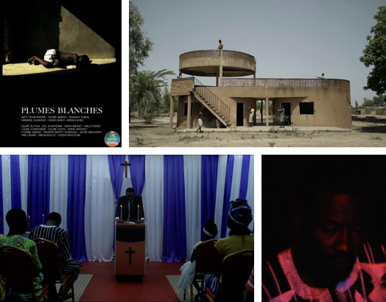

Synopsis:

A story of good and evil, internment and redemption, Plumes Blanches tells the story of Alain, a young burkinabe boy accused of witchcraft and his audacious attempt to escape from the impending desolation.

Film Title: Plumes Blanches (original language), White Feathers (English)
Director/Writer: Leul Shoaferaw
Producer: Sarah Bariset
Production: Cine Nomad School, an international production program initiated by Cinéfabrique, a film school in Lyon, France.

Key Cast
Kevin Kabore
Désiré Yameogo
Rihanata Zongo
Dramane Ouedraogo

Crew
Assistant Director: Louise Courvoisier
Cinematographer: Coline Costes
Camera Assistant: Jacob Gbechoevi
Sound: Etienne Jamond
Sound Assistant: Prosper Raffet Houessou
Locations Manager and Set Designer: Malick Boro
Make Up and Styling: Ama Lingani
Editor: Sarah Grosset

Technical Specifications

Film Type: Short
Runtime: 10 minutes 21 seconds
Completion Year: 2018
Production Budget: 3,000 EUR
Country of Origin: Ethiopia, France
Country of Filming: Burkina Faso
Film Language: French
Shooting Format: Digital Color

Contact:
- Leul Shoaferaw (Writer/Director):
leulshoaferaw@gmail.com
+251912714665 Addis Ababa, Ethiopia

- Sarah Bariset (Producer):
sarah.bariset@gmail.com
+33668193317 Paris, France

Social Media Contacts:
Leul Shoaferaw:
Facebook: https://www.facebook.com/dionysus.adoneus
Instagram: @loelshoaferaw

Sarah Bariset: Facebook: https://www.facebook.com/profile.php?id=1093616041
Instagram: @whitevo

Festivals and Awards to date:
- Festival PanAfrican Du Cinema Et De La Television De Ouagadougou (FESPACO) (Premiere)
- Addis International Film Festival (AIFF) (Official Selection)
- New York African Film Festival (NYAFF) (Official Selection)
- Durban International Film Festival (DIFF)

